**AI NOTES**

### Unit-I

**What is artificial intelligence (AI)?**

Artificial intelligence is the simulation of human intelligence processes by machines, especially computer systems. Specific applications of AI include [expert systems](https://www.techtarget.com/searchenterpriseai/definition/expert-system), [natural language processing](https://www.techtarget.com/searchenterpriseai/definition/natural-language-processing-NLP), speech recognition and [machine vision](https://www.techtarget.com/searchenterpriseai/definition/machine-vision-computer-vision).

**How does AI work?**

As the hype around AI has accelerated, vendors have been scrambling to promote how their products and services use it. Often, what they refer to as AI is simply a component of the technology, such as [machine learning](https://www.techtarget.com/searchenterpriseai/definition/machine-learning-ML). AI requires a foundation of specialized hardware and software for writing and training machine learning algorithms. No single programming language is synonymous with AI, but Python, R, Java, C++ and Julia have features popular with AI developers.

Ex :- ChatGTP , Alexa , Google assistance etc.

# **History of Artificial Intelligence**

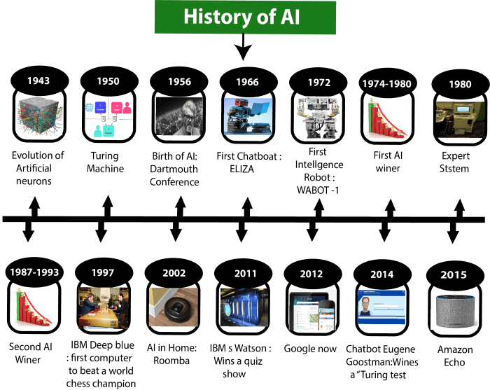Artificial Intelligence is not a new word and not a new technology for researchers. This technology is much older than you would imagine. Even there are the myths of Mechanical men in Ancient Greek and Egyptian Myths. Following are some milestones in the history of AI which defines the journey from the AI generation to till date development.

# **Current Status of AI**

The current status of AI is in the Theory of Mind State.

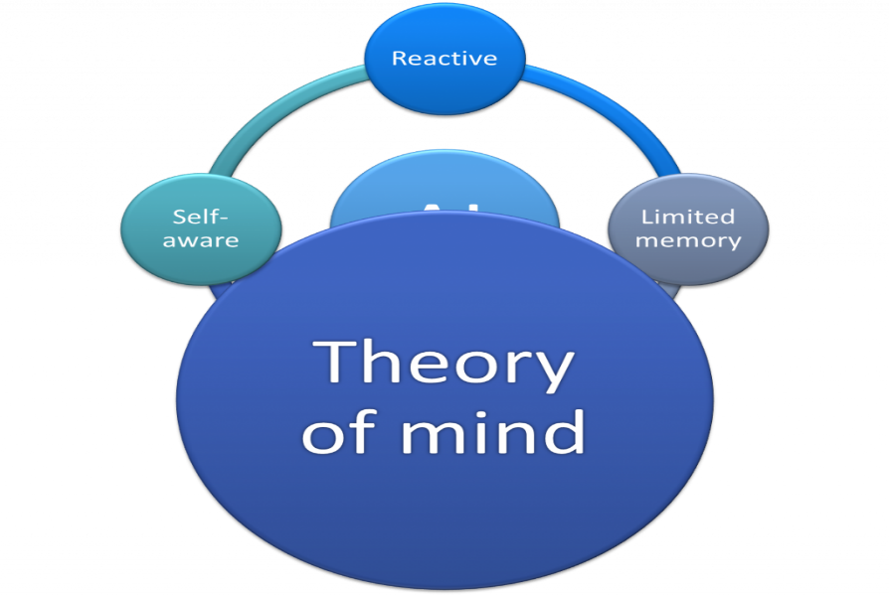In Theory of Mind AI a machine is able to decide like any human. It seems that the machine have a mind in it. It can think emotionally. Many data from the surrounding is saved in the machine. Machine analyze these data and show a output in a certain condition based on those data.

## **Summary of the Current Status of AI**

* Technologies are more enhanced than previous time. Any technological solution is available to the industries.
* Voice assistants helps in many work such as in IT, automotive and retail industries.
* Chatbots are part of Current Status of AI. Which have reduced the hassle of replying huge common messages manually.
* AI technology has made to deploy any mobile devices and apps in one of the easiest ways across industries.
* Cloud Service has been more easier in the current status of AI.
* Emerging AI technologies include augmented intelligence such as some forms of face recognition, which seeks to enhance human intelligence and edge AI, where AI algorithms are processed locally without the need for an internet connection.

## **Future of AI**

The Future state of AI is Self Aware AI. Where the machine will be aware before any incident happens. If any incident is seems to be occur AI will provide a signal from the previous experience, knowledge and saved data.

Self Aware AI is not established yet. So, this will be the future status of AI.

# **Scope of AI (AI Careers)**

Fresher's should analyze their competencies and skills and choose a better AI role with the potential for upward mobility. The future scope of Artificial Intelligence continues to grow due to new job roles and advancements in the AI field. The various roles in an AI career are as follows:

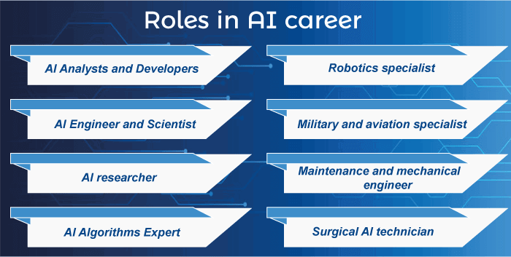

* AI Analysts and Developers
* AI Engineer and Scientist
* AI researcher
* AI Algorithms Expert
* Robotics specialist
* Military and aviation specialist
* Maintenance and mechanical engineer
* Surgical AI technician

### The future of AI

The future of [Artificial Intelligence](https://www.javatpoint.com/artificial-intelligence-tutorial) is bright in India, with many organizations opting for AI automation. It is essential to understand the recent developments in AI to find suitable job roles based on your competencies.

The scope of Artificial Intelligence is limited to domestic and commercial purposes as the medical and aviation sectors are also using AI to improve their services. If AI is outperforming human efforts, then opting for AI automation will reduce costs in the long run for a business.

Automation in operational vehicles has created a buzz in the logistics industry as it is expected that automated **trucks/vehicles** may soon be used.

Due to the bright scope of Artificial Intelligence in the future, the number of AI start-ups is expected to increase in the coming years. Indicating the opportunities, the number of AI start-ups in India has increased significantly.

Moreover, India's talent gap for specialist AI developers is huge, and AI experts are needed by businesses more than ever. Businesses don't want to miss out on any technology that can revolutionize their business processe.

# **Agents in Artificial Intelligence**

An AI system can be defined as the study of the rational agent and its environment. The agents sense the environment through sensors and act on their environment through actuators. An AI agent can have mental properties such as knowledge, belief, intention, etc.

## **What is an Agent?**

An agent can be anything that perceiveits environment through sensors and act upon that environment through actuators. An Agent runs in the cycle of **perceiving**, **thinking**, and **acting**. An agent can be:

* **Human-Agent:** A human agent has eyes, ears, and other organs which work for sensors and hand, legs, vocal tract work for actuators.
* **Robotic Agent:** A robotic agent can have cameras, infrared range finder, NLP for sensors and various motors for actuators.
* **Software Agent:** Software agent can have keystrokes, file contents as sensory input and act on those inputs and display output on the screen.

Hence the world around us is full of agents such as thermostat, cellphone, camera, and even we are also agents.

Before moving forward, we should first know about sensors, effectors, and actuators.

**Sensor:** Sensor is a device which detects the change in the environment and sends the information to other electronic devices. An agent observes its environment through sensors.

**Actuators:** Actuators are the component of machines that converts energy into motion. The actuators are only responsible for moving and controlling a system. An actuator can be an electric motor, gears, rails, etc.

**Effectors:** Effectors are the devices which affect the environment. Effectors can be legs, wheels, arms, fingers, wings, fins, and display screen.

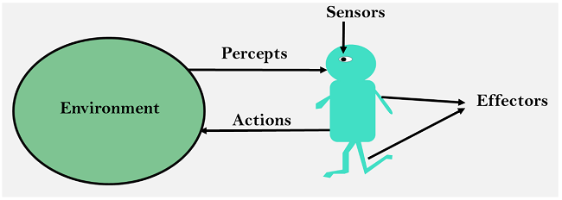

## **Intelligent Agents:**

An intelligent agent is an autonomous entity which act upon an environment using sensors and actuators for achieving goals. An intelligent agent may learn from the environment to achieve their goals. A thermostat is an example of an intelligent agent.

Following are the main four rules for an AI agent:

* **Rule 1:** An AI agent must have the ability to perceive the environment.
* **Rule 2:** The observation must be used to make decisions.
* **Rule 3:** Decision should result in an action.
* **Rule 4:** The action taken by an AI agent must be a rational action.

# **Environment in AI**

An environment is everything in the world which surrounds the agent, but it is not a part of an agent itself. An environment can be described as a situation in which an agent is present.

The environment is where agent lives, operate and provide the agent with something to sense and act upon it. An environment is mostly said to be non-feministic.

## **Features of Environment**

As per Russell and Norvig, an environment can have various features from the point of view of an agent:

1. Fully observable vs Partially Observable
2. Static vs Dynamic
3. Discrete vs Continuous
4. Deterministic vs Stochastic
5. Single-agent vs Multi-agent
6. Episodic vs sequential
7. Known vs Unknown
8. Accessible vs Inaccessible

## **1. Fully observable vs Partially Observable:**

* If an agent sensor can sense or access the complete state of an environment at each point of time then it is **a fully observable** environment, else it is **partially observable**.
* 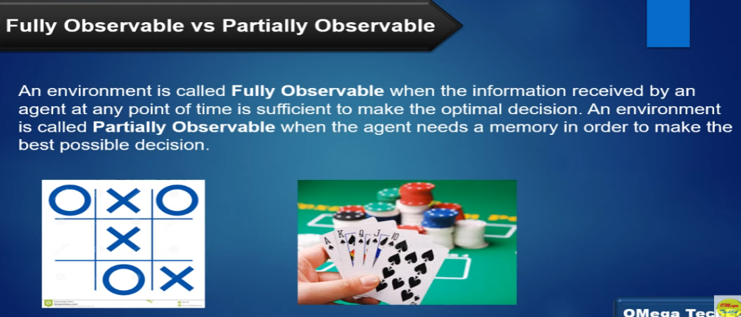

## **2. Deterministic vs Stochastic:**

* If an agent's current state and selected action can completely determine the next state of the environment, then such environment is called a deterministic environment.
* A stochastic environment is random in nature and cannot be determined completely by an agent.
* In a deterministic, fully observable environment, agent does not need to worry about uncertainty.
* 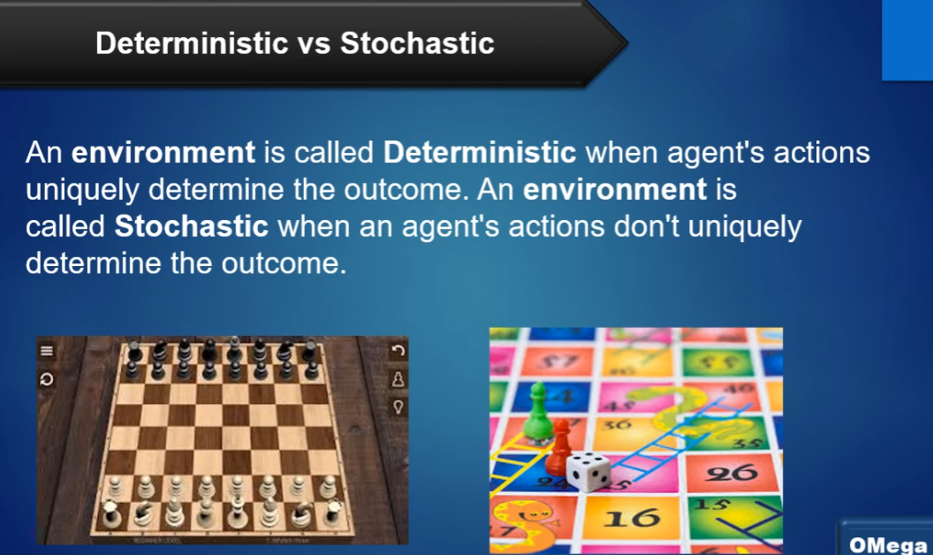

## **3. Episodic vs Sequential:**

* In an episodic environment, there is a series of one-shot actions, and only the current percept is required for the action.
* However, in Sequential environment, an agent requires memory of past actions to determine the next best actions.
* 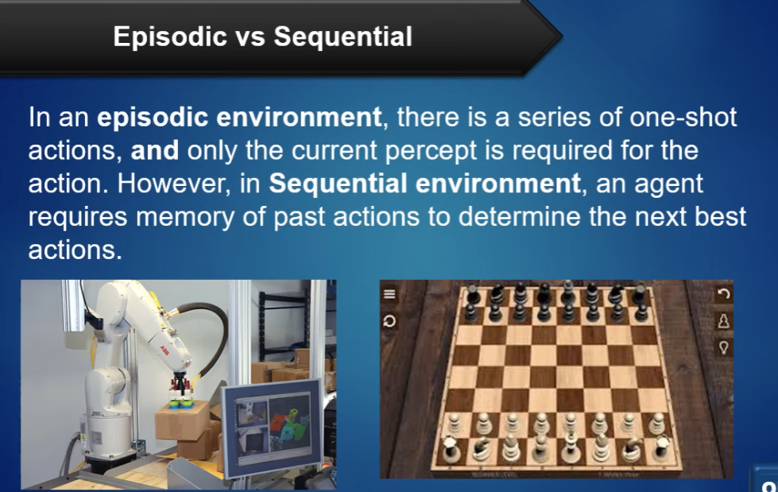

## **4. Single-agent vs Multi-agent**

* If only one agent is involved in an environment, and operating by itself then such an environment is called single agent environment.
* However, if multiple agents are operating in an environment, then such an environment is called a multi-agent environment.
* The agent design problems in the multi-agent environment are different from single agent environment.
* 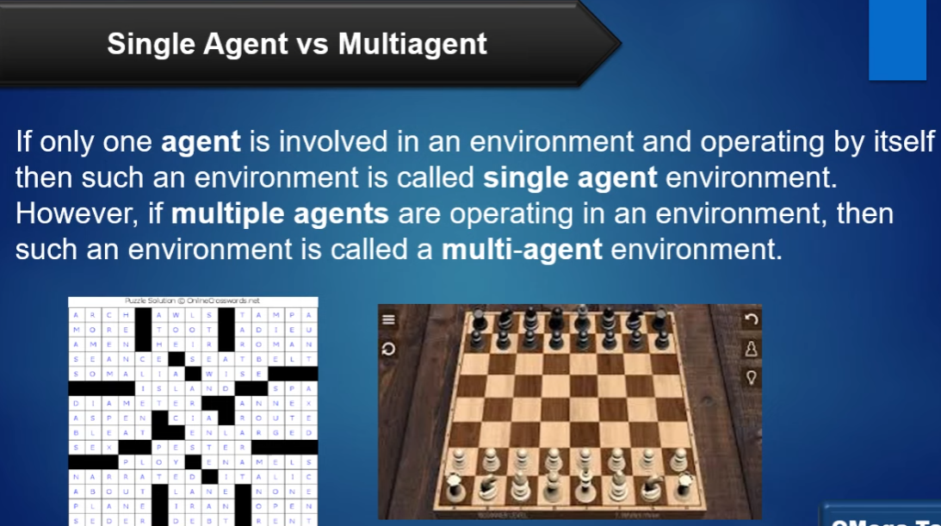

## **5. Static vs Dynamic:**

* If the environment can change itself while an agent is deliberating then such environment is called a dynamic environment else it is called a static environment.
* Static environments are easy to deal because an agent does not need to continue looking at the world while deciding for an action.
* However for dynamic environment, agents need to keep looking at the world at each action.
* Taxi driving is an example of a dynamic environment whereas Crossword puzzles are an example of a static environment.
* 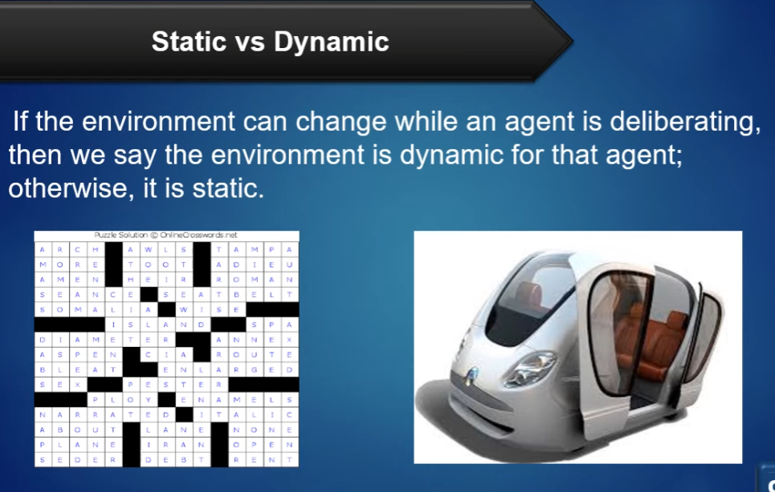

## **6. Discrete vs Continuous:**

* If in an environment there are a finite number of percepts and actions that can be performed within it, then such an environment is called a discrete environment else it is called continuous environment.
* A chess gamecomes under discrete environment as there is a finite number of moves that can be performed.
* A self-driving car is an example of a continuous environment.
* 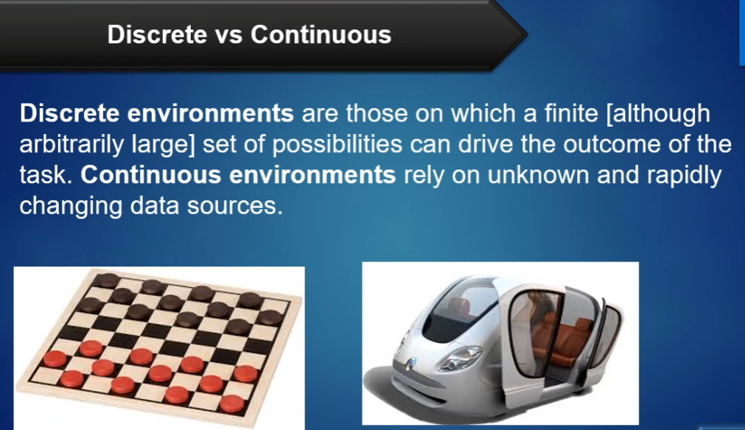

## **7. Known vs Unknown**

* Known and unknown are not actually a feature of an environment, but it is an agent's state of knowledge to perform an action.
* In a known environment, the results for all actions are known to the agent. While in unknown environment, agent needs to learn how it works in order to perform an action.
* It is quite possible that a known environment to be partially observable and an Unknown environment to be fully observable.

## **8. Accessible vs Inaccessible**

* If an agent can obtain complete and accurate information about the state's environment, then such an environment is called an Accessible environment else it is called inaccessible.
* An empty room whose state can be defined by its temperature is an example of an accessible environment.
* Information about an event on earth is an example of Inaccessible environment.
* 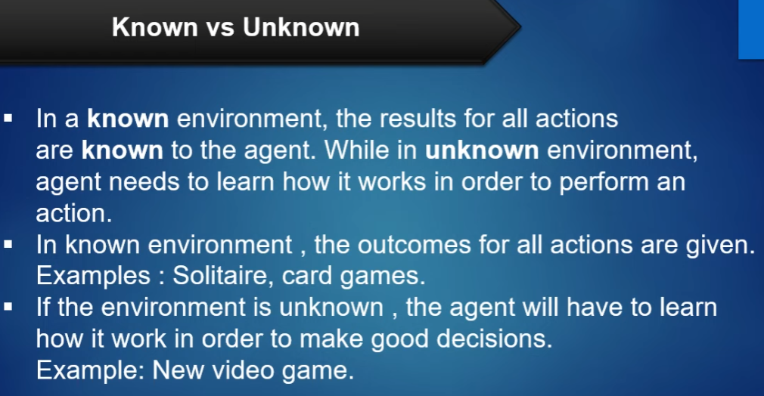

**Problem formulation**

Problem formulation is the process of deciding what actions and states to consider to go given goal. The process of looking for a sequence of actions that reaches the goal is called search. A search algorithm takes a problem as input and returns a solution in the form of an action sequence.

Problem formulation is help to agent to reach goal from initial /starting state.

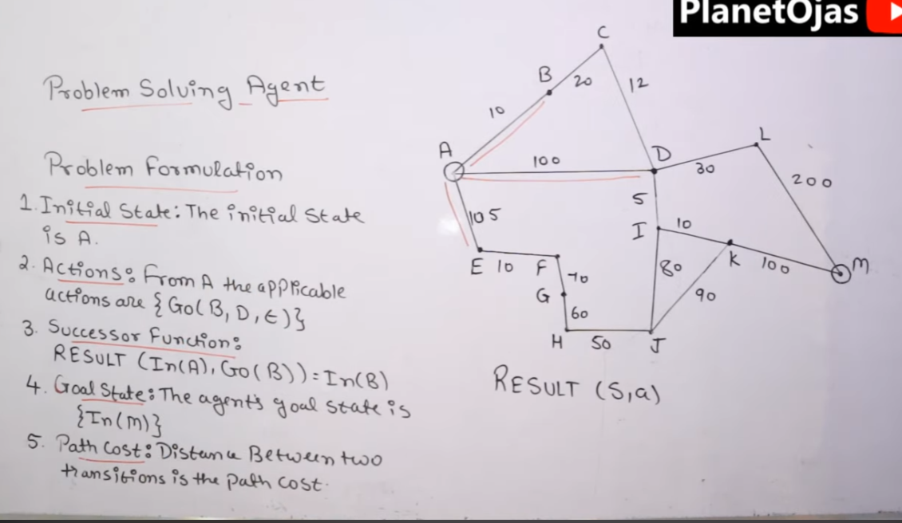

**Review of Tree and Graph structure**

**Tree:-** A tree is a connected acyclic graph—every node has an edge to another node, and no cycles exist. In a tree, the value or object represented at a specific point is called a node. Trees typically have a single root node with zero or more child nodes that could contain subtrees.

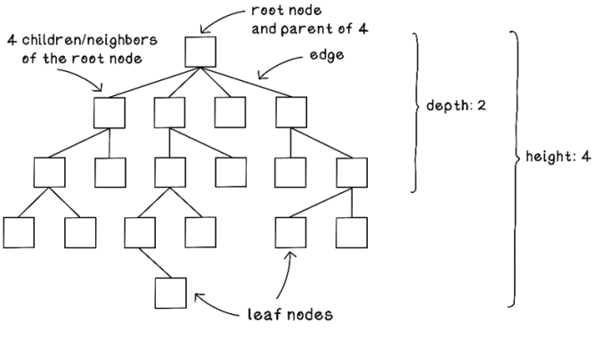

**Graph:-** In AI, a graph typically refers to a mathematical representation of data that shows the relationship between different objects or entities. A graph is a collection of nodes (also called vertices) that are connected by edges (also called arcs or links).

In machine learning, graphs are commonly used to represent data structures or models, such as neural networks, decision trees, and Bayesian networks. Graphs are useful for representing complex relationships between variables and for making predictions or classifications based on those relationships.

For example, in a social network analysis, a graph can be used to represent the connections between individuals in a network. Each person would be represented by a node, and their connections to other people would be represented by edges between the nodes. By analyzing the graph, it may be possible to identify key influencers in the network, or to predict the spread of information or ideas through the network.

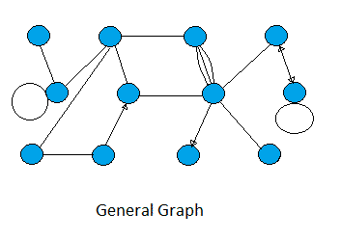

**Convert Graph into Tree:-**

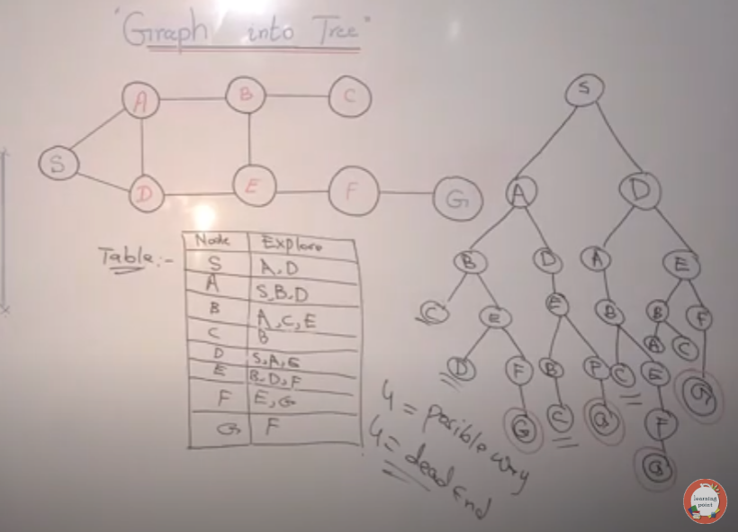

**State space representation/search**

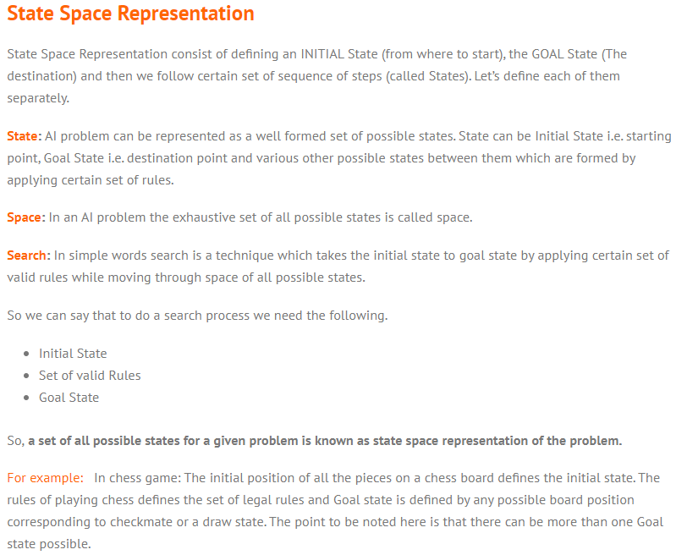

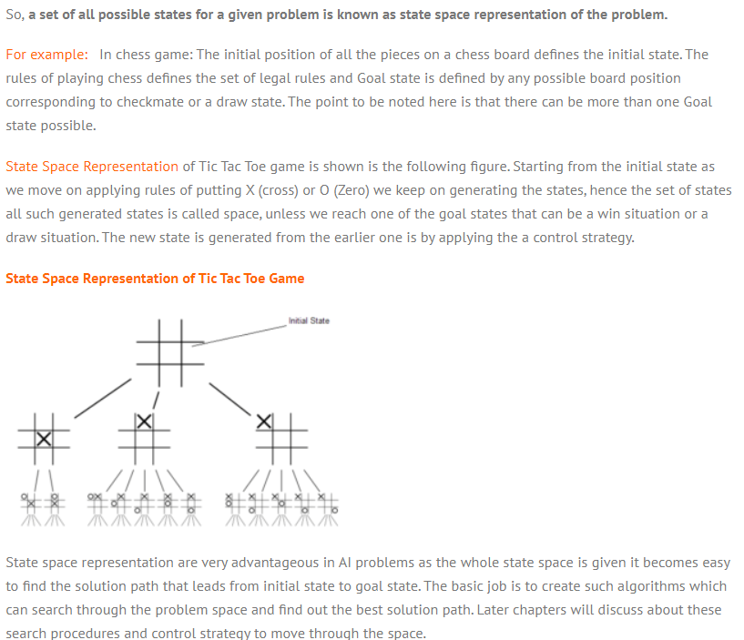

**Search graph in AI**

In AI, a search graph is a type of graph that is used to represent the states and transitions of a search problem. Search problems arise in various areas of AI, such as planning, natural language processing, game playing, and optimization.

A search graph consists of nodes and edges, where each node represents a state in the search problem, and each edge represents a transition from one state to another. For example, in a puzzle-solving problem, each node could represent a different configuration of the puzzle pieces, and each edge could represent the movement of a single piece.

Examples of search algorithms include depth-first search, breadth-first search, and A* search.

**BFS:-** BFS is trevelthrough levels(Pahle ek lavel ko search krega uske baad dusare lavel pe jayega).

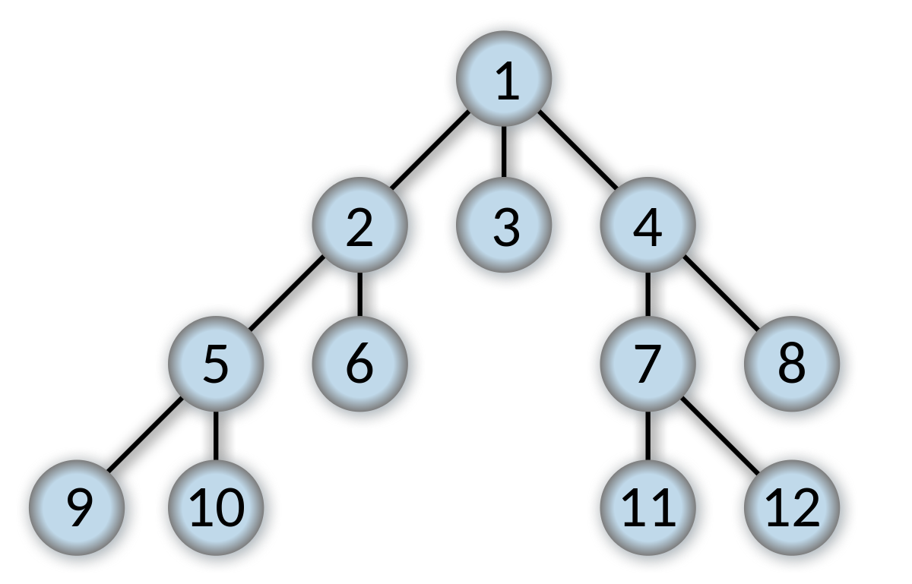



**DFS:-** DFS is travel through backtracking(pahle ye defth(niche) tak jata h fir prents node check krta h).



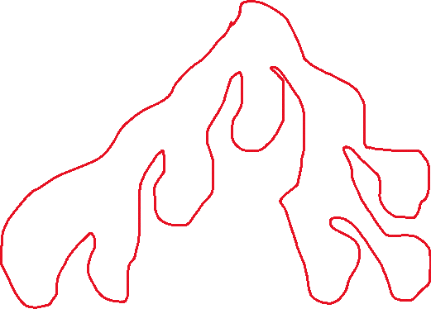

# **Search Tree**

A search tree is a [**data structure**](https://www.easytechjunkie.com/what-is-a-data-structure.htm) used in computer programming to contain and organize a list of data.

**Types of search tree**

### 1. Binary search tree

### 2. B-tree

### 3. (a,b)-tree

### 4. Ternary search tree

### Binary search tree:-

A binary search tree follows some order to arrange the elements. In a Binary search tree, the value of left node must be smaller than the parent node, and the value of right node must be greater than the parent node. This rule is applied recursively to the left and right subtrees of the root.

Let's understand the concept of Binary search tree with an example.

### Binary Search tree

### Advantages of Binary search tree:-

### In BST , easy to search

* As compared to array and linked lists, insertion and deletion operations are faster in BST.

### B-tree:-

B Tree is a specialized m-way tree that can be widely used for disk access. A B-Tree of order m can have at most m-1 keys and m children. One of the main reason of using B tree is its capability to store large number of keys in a single node and large key values by keeping the height of the tree relatively small.

A B tree of order m contains all the properties of an M way tree. In addition, it contains the following properties.

1. Every node in a B-Tree contains at most m children.
2. Every node in a B-Tree except the root node and the leaf node contain at least m/2 children.
3. The root nodes must have at least 2 nodes.
4. All leaf nodes must be at the same level.

It is not necessary that, all the nodes contain the same number of children but, each node must have m/2 number of nodes.

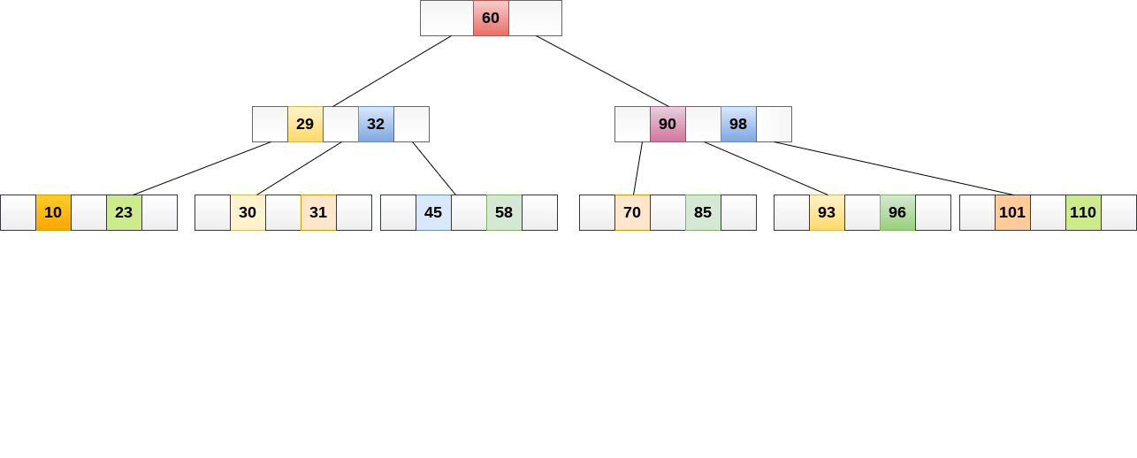A B tree of order 4 is shown in the following image.

### (a,b)-tree:-

(a,b)-trees are a type of balanced tree data structure that are used to store and retrieve ordered data.They are similar to other balanced tree structures such as B-Trees, red-black trees and AVL trees, but they have a more relaxed balance condition that allows them to have better performance in

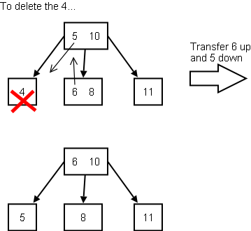

### Ternary search tree:-

Ternary Search Tree is a trie data structure commonly used as a low-memory alternative to trie in various applications such as spell check and looking for nearby neighbors. To comprehend the ternary search tree, we must first grasp the concept of the trie.

A trie, also known as a digital tree, radix tree, or prefix tree, is a type of search tree, an ordered tree data structure used to hold a dynamic set or associative array using strings as keys.

## **Representation of Ternary Search Trees**

In the trie (standard) data structure, each node contains 26 pointers for its children, but in a ternary search tree, each node contains only 3 pointers:

* The left pointer points to the node whose value is lower than the current node's value.
* The equal pointer leads to a node whose value is the same as the current node's value.
* The right pointer leads to the node whose value exceeds the current node's value.

### Ternary Search Trees

### Unit-II

### Rendom search

Random search is a hyperparameter tuning technique used in machine learning and artificial intelligence to find the optimal values of hyperparameters for a given model.

Hyperparameters are the parameters of a model that are not learned from data, but are set manually by the data scientist or researcher, such as learning rate, batch size, regularization strength, and number of hidden layers in a neural network.

Random search involves randomly selecting values for each hyperparameter from a specified range of values, and then evaluating the model's performance on a validation set using each combination of hyperparameters. This process is repeated for a specified number of iterations, and the combination of hyperparameters that produces the best performance is selected as the optimal hyperparameters for the model.

Random search can be more efficient than other hyperparameter tuning techniques, such as grid search, because it explores the hyperparameter space more efficiently and is less likely to get stuck in local optima. However, it may not be the best choice for all models and datasets, and other techniques such as Bayesian optimization or evolutionary algorithms may be more suitable in some cases.

**Seach with closed and open list**

# **DFS (Depth First Search) algorithm**

In this article, we will discuss the DFS algorithm in the data structure. It is a recursive algorithm to search all the vertices of a tree data structure or a graph. The depth-first search (DFS) algorithm starts with the initial node of graph G and goes deeper until we find the goal node or the node with no children.

Because of the recursive nature, stack data structure can be used to implement the DFS algorithm. The process of implementing the DFS is similar to the BFS algorithm.

DFS is use stack algorithm . it is use LIFO(Last in first out) technique.

The step by step process to implement the DFS traversal is given as follows -

1. First, create a stack with the total number of vertices in the graph.
2. Now, choose any vertex as the starting point of traversal, and push that vertex into the stack.
3. After that, push a non-visited vertex (adjacent to the vertex on the top of the stack) to the top of the stack.
4. Now, repeat steps 3 and 4 until no vertices are left to visit from the vertex on the stack's top.
5. If no vertex is left, go back and pop a vertex from the stack.
6. Repeat steps 2, 3, and 4 until the stack is empty.

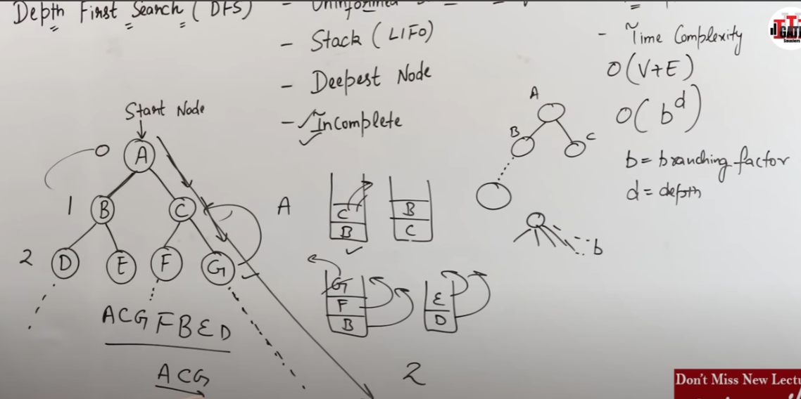

# **BFS(**Breadth-first search **)**

BFS is a searching algoritham . it use to search the data . BFS is search the data in level wise. It is use queue data structure to trevers one node to other node.

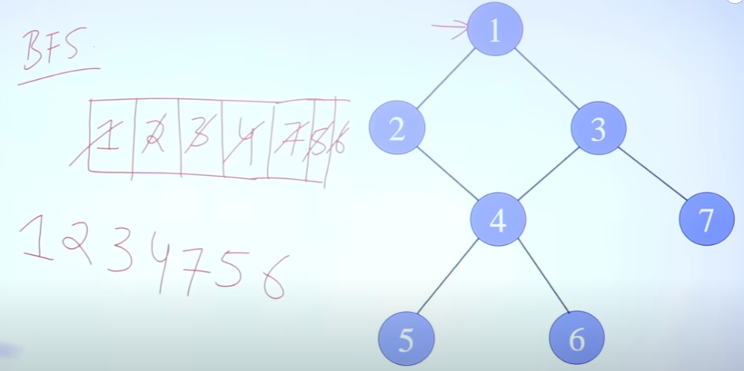

# **Uninformed Search Algorithms**

**Uninformed search is a class of general-purpose search algorithms which operates in brute force-way. Uninformed search algorithms do not have additional information about state or search space other than how to traverse the tree, so it is also called blind search.**

**Following are the various types of uninformed search algorithms:**

1. **Breadth-first Search**
2. **Depth-first Search**
3. **Depth-limited Search**
4. **Iterative deepening depth-first search**
5. **Uniform cost search**
6. **Bidirectional Search**

## **3. Depth-Limited Search Algorithm:**

A depth-limited search algorithm is similar to depth-first search with a limit. This algorithm solve the infinite loop of Depth first search. In Depth-limited search we can limit for node to trevers. Depth-limited search can solve the drawback of the infinite path in the Depth-first search. In this algorithm, the node at the depth limit will treat as it has no successor nodes further.

Depth-limited search can be terminated with two Conditions of failure:

* Standard failure value: It indicates that problem does not have any solution.
* Cutoff failure value: It defines no solution for the problem within a given depth limit.

**Advantages:**

Depth-limited search is Memory efficient.

**Disadvantages:**

* Depth-limited search also has a disadvantage of incompleteness.
* It may not be optimal if the problem has more than one solution.

**Iterative deepening depth-first search:-**

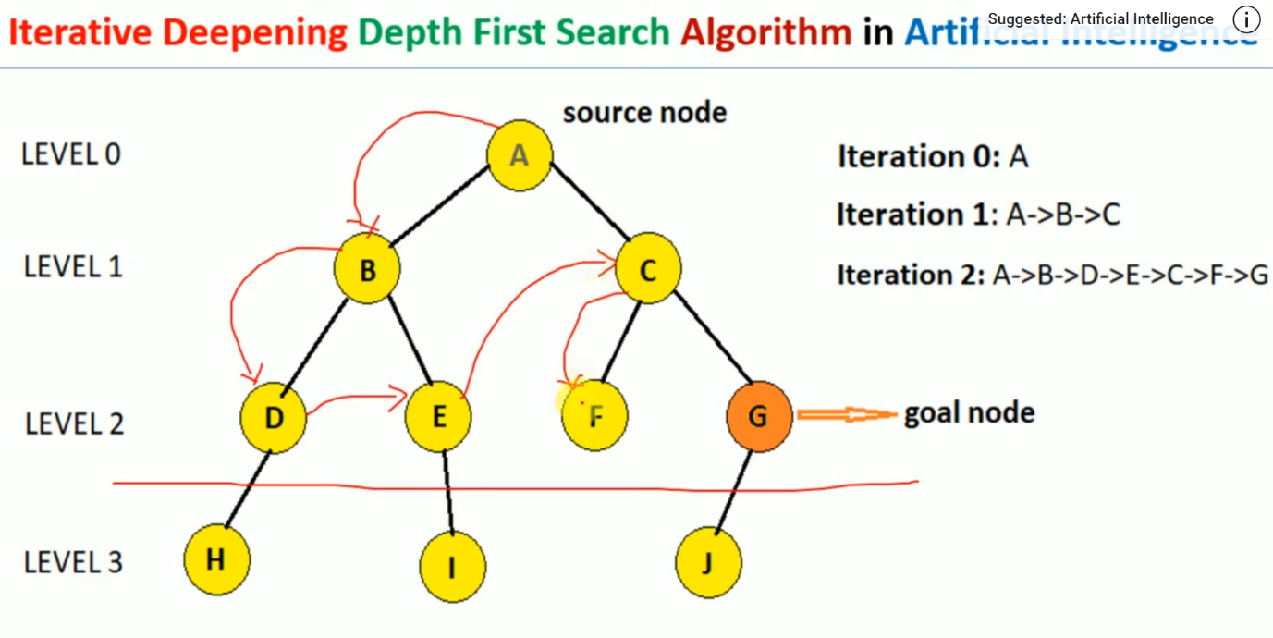

## **Iterative deepeningdepth-first Search:**

The iterative deepening algorithm is a combination of DFS and BFS algorithms. This search algorithm finds out the best depth limit and does it by gradually increasing the limit until a goal is found.

This algorithm performs depth-first search up to a certain "depth limit", and it keeps increasing the depth limit after each iteration until the goal node is found.

This Search algorithm combines the benefits of Breadth-first search's fast search and depth-first search's memory efficiency.

The iterative search algorithm is useful uninformed search when search space is large, and depth of goal node is unknown.

**Advantages:**

* Itcombines the benefits of BFS and DFS search algorithm in terms of fast search and memory efficiency.

**Disadvantages:**

* The main drawback of IDDFS is that it repeats all the work of the previous phase.

## **Uniform-cost Search Algorithm:**

Uniform-cost search is a searching algorithm used for traversing a weighted tree or graph. This algorithm comes into play when a different cost is available for each edge. The primary goal of the uniform-cost search is to find a path to the goal node which has the lowest cumulative cost.

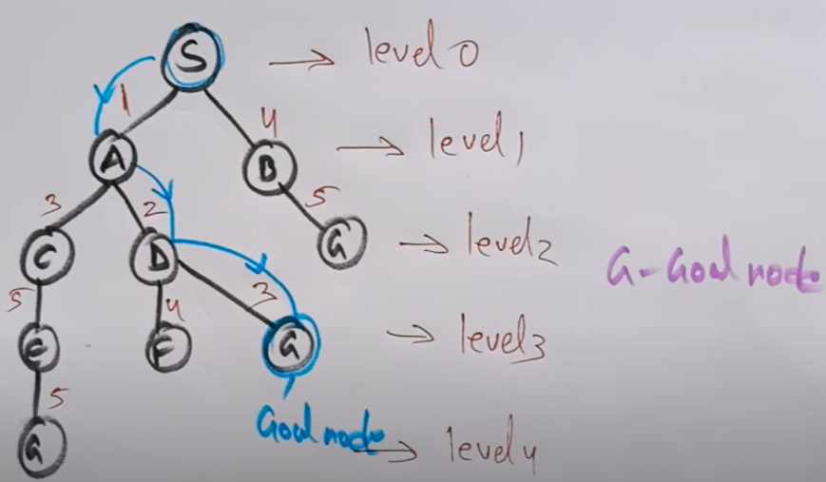

## **Bidirectional Search Algorithm:**

**Bidirectional search algorithm runs two simultaneous searches, one form initial state called as forward-search and other from goal node called as backward-search, to find the goal node. Bidirectional search replaces one single search graph with two small subgraphs in which one starts the search from an initial vertex and other starts from goal vertex. The search stops when these two graphs intersect each other.**

**Bidirectional search can use search techniques such as BFS, DFS, DLS, etc.**

**Advantages:**

* Bidirectional search is fast.
* Bidirectional search requires less memory

**Disadvantages:**

* Implementation of the bidirectional search tree is difficult.
* **In bidirectional search, one should know the goal state in advance.**

### Example:

In the below search tree, bidirectional search algorithm is applied. This algorithm divides one graph/tree into two sub-graphs. It starts traversing from node 1 in the forward direction and starts from goal node 16 in the backward direction.

The algorithm terminates at node 9 where two searches meet.

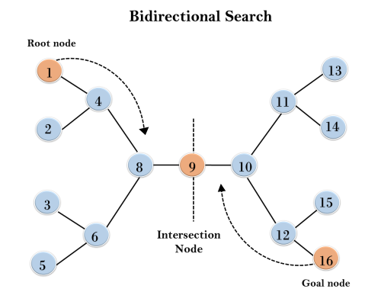

## **What is Heuristics search?**

Heurstics search is a search technique . it is a shor-cut method to searching . it takes less time to travers from start state to goal state.it may not give best/optimization solution.

A heuristic search is a technique that is used to solve a problem faster than the classic methods. These techniques are used to find the approximate solution of a problem when classical methods do not. Heuristics are said to be the problem-solving techniques that result in practical and quick solutions.

Heuristics are strategies that are derived from past experience with similar problems. Heuristics use practical methods and shortcuts used to produce the solutions that may or may not be optimal, but those solutions are sufficient in a given limited timeframe.

## **Why do we need heuristics?**

Heuristics are used in situations in which there is the requirement of a short-term solution. On facing complex situations with limited resources and time, Heuristics can help the companies to make quick decisions by shortcuts and approximated calculations. Most of the heuristic methods involve mental shortcuts to make decisions on past experiences.

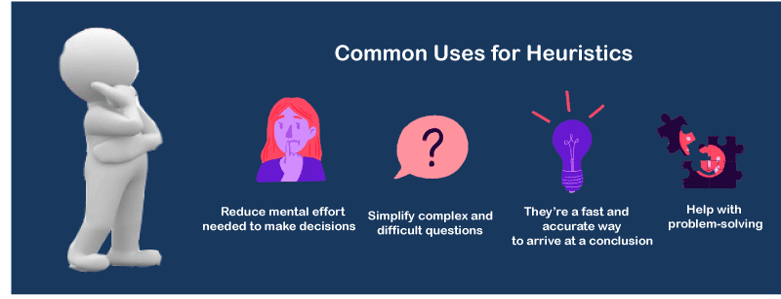

The heuristic method might not always provide us the best solution, but it is sure that it helps us find a good solution in a reasonable time.

**We can perform the Heuristic techniques into two categories:**

### Direct Heuristic Search techniques in AI

It includes Blind Search, Uninformed Search, and Blind control strategy. These search techniques are not always possible because it have need much memory and time.

The examples of Direct Heuristic search techniques include Breadth-First Search (BFS) and Depth First Search (DFS).

### Weak Heuristic Search techniques in AI

It includes Informed Search, Heuristic Search, and Heuristic control strategy. These techniques are helpful when they are applied properly to the right types of tasks. They usually require domain-specific information.

The examples of Weak Heuristic search techniques include Best First Search (BFS) and A*.

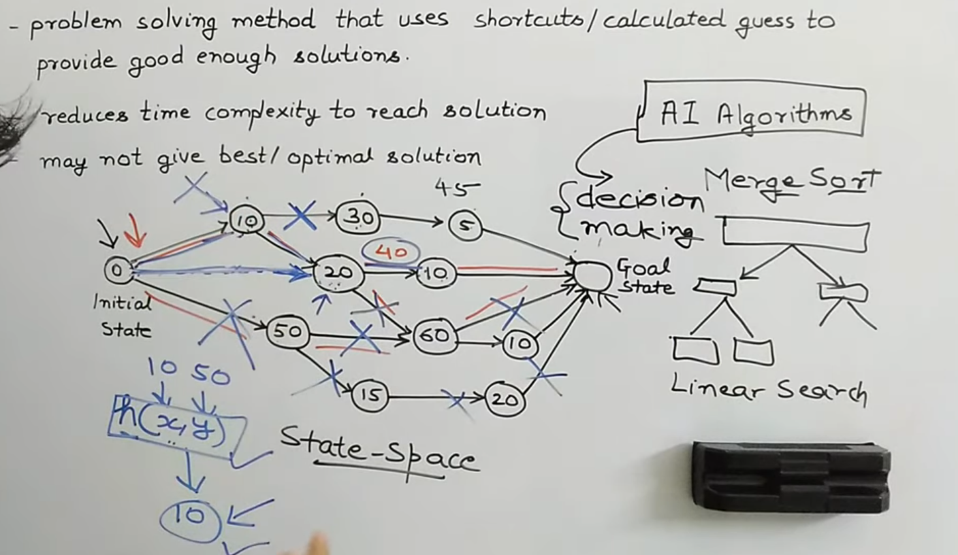

Hueristic search video :- <https://youtu.be/GL28VbiFkD0>

**A* search Algorithm**

**What is A* Search Algorithm?**   
A* Search algorithm is one of the best and popular technique used in path-finding and graph traversals.

**Why A* Search Algorithm?**   
Informally speaking, A* Search algorithms, unlike other traversal techniques, it has “brains”. What it means is that it is really a smart algorithm which separates it from the other conventional algorithms. This fact is cleared in detail in below sections.   
And it is also worth mentioning that many games and web-based maps use this algorithm to find the shortest path very efficiently (approximation).

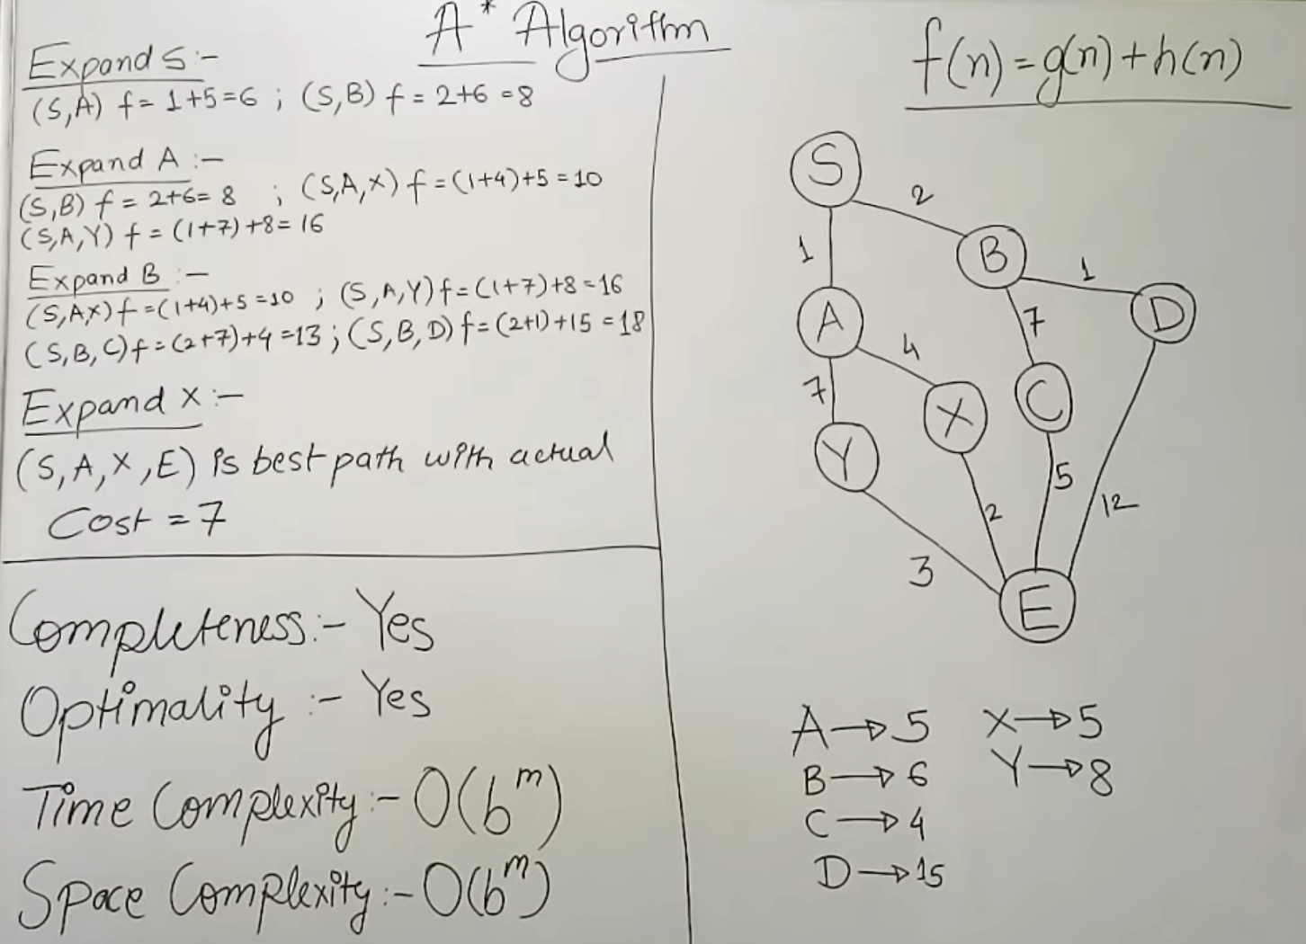

# **8-Puzzle Problem**

“It has set off a 3x3 board having 9 block spaces out of which 8 blocks having tiles bearing number from 1 to 8. One space is left blank. The tile adjacent to blank space can move into it. We have to arrange the tiles in a sequence for getting the goal state”.

### Procedure:

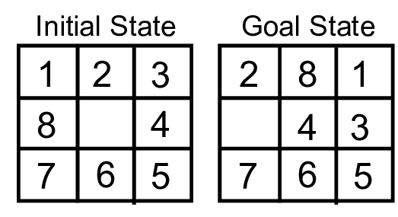

The 8-puzzle problem belongs to the category of “sliding block puzzle” type of problem. The 8-puzzle i s a square tray in which eight square tiles are placed. The remaining ninth square is uncovered. Each tile in the tray has a number on it.

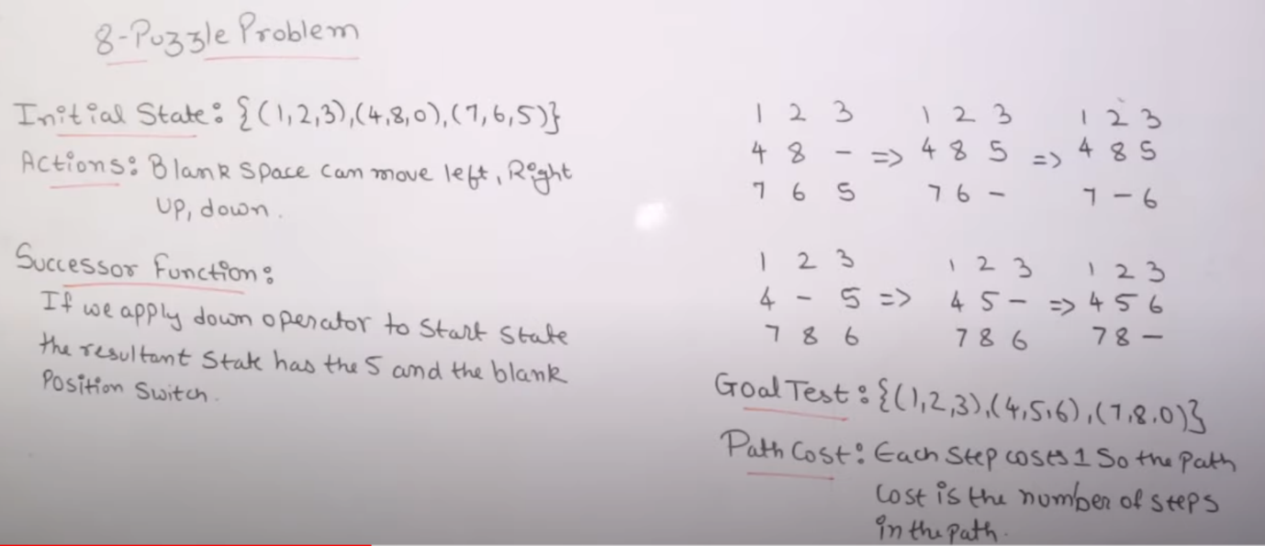

**Game Searching**

Game searching is a technique to search minimum and maximum. Minimum and maximum is use in game playing and game searching. In game playing maximum is only for winner and minimum is only for losser.

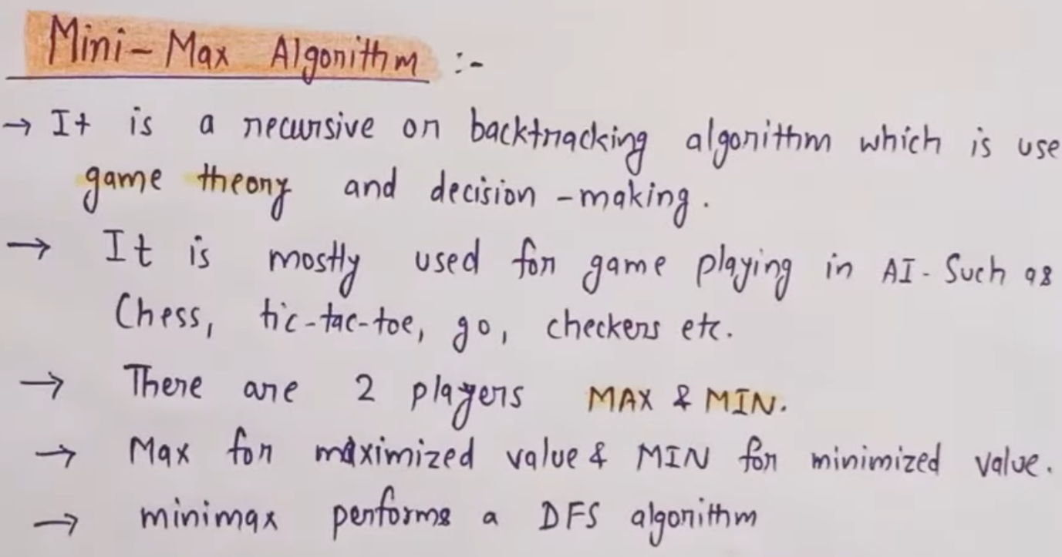

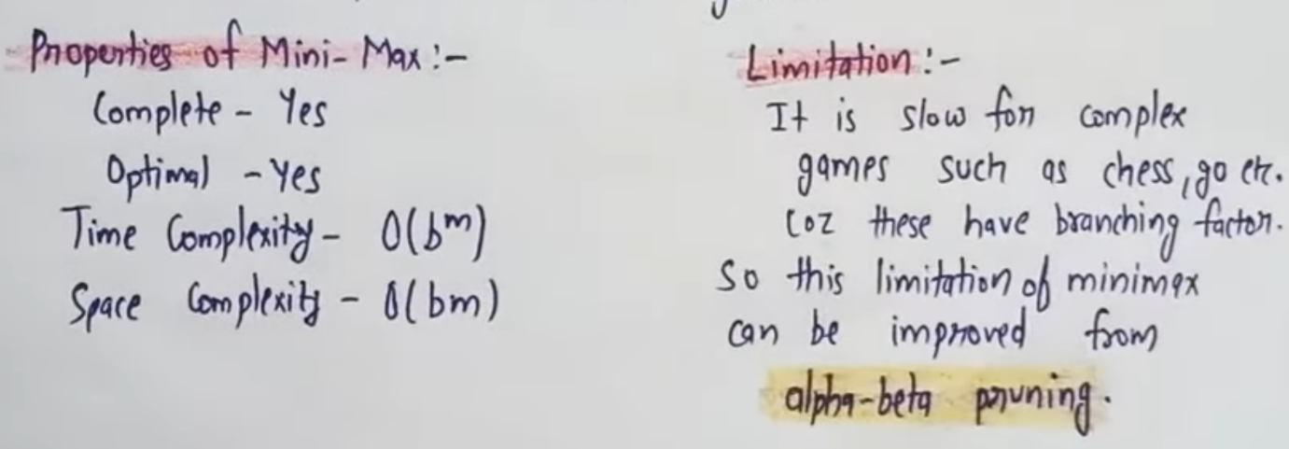

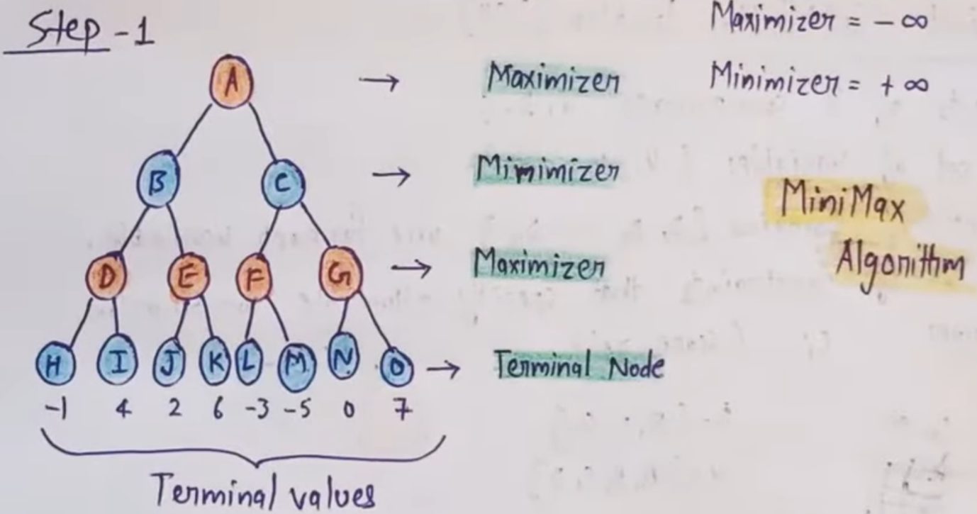

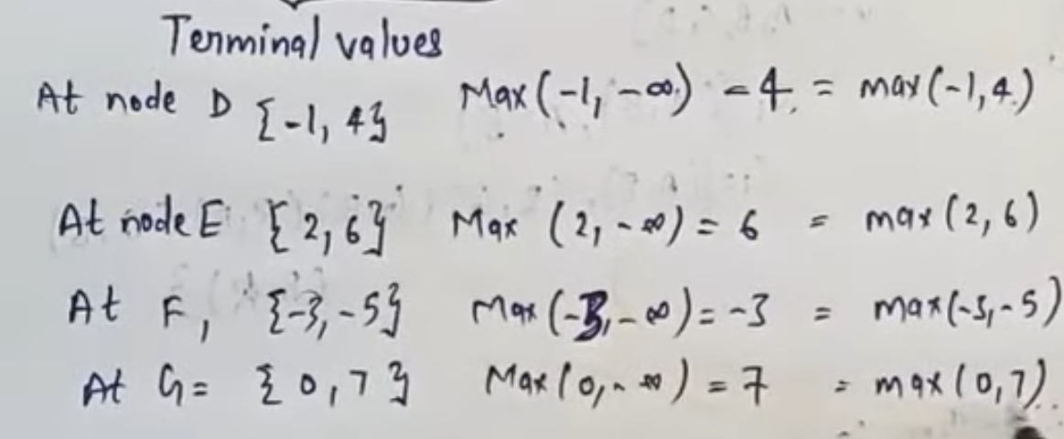

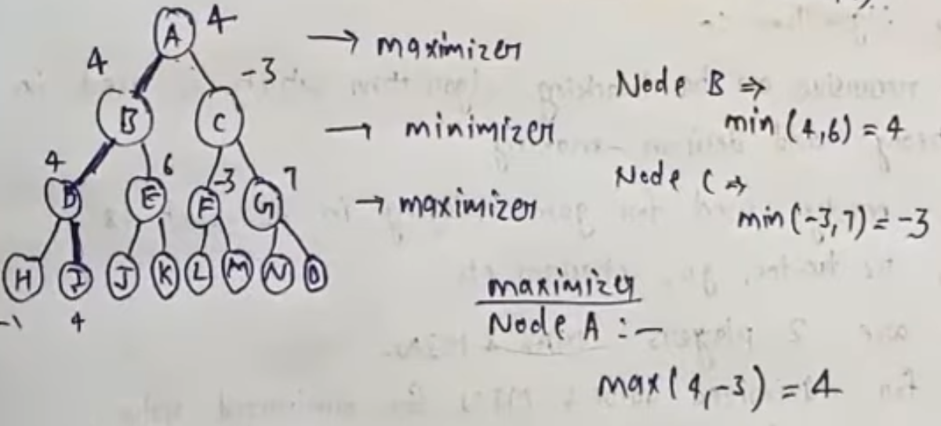

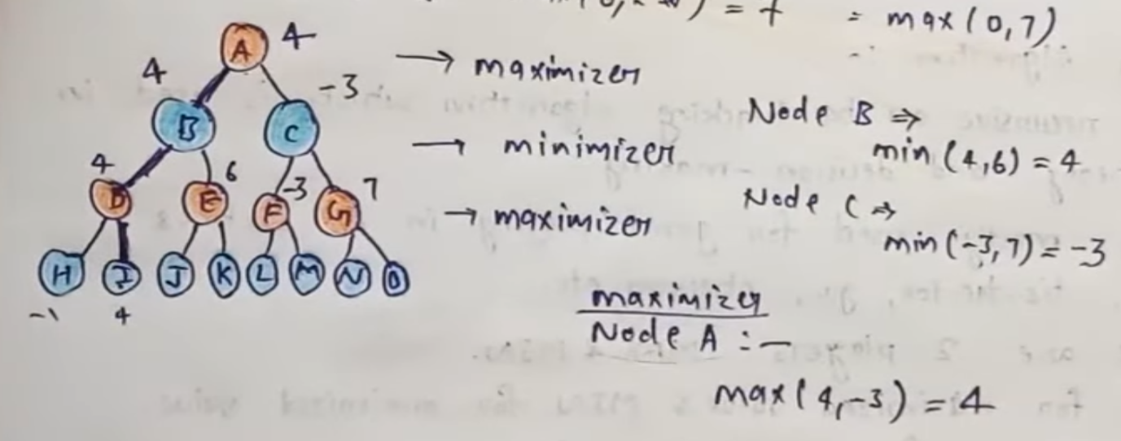

Link of game playing video :- https://youtu.be/y04jOqDJurs

**UNIT – III**

# **Probabilistic reasoning**

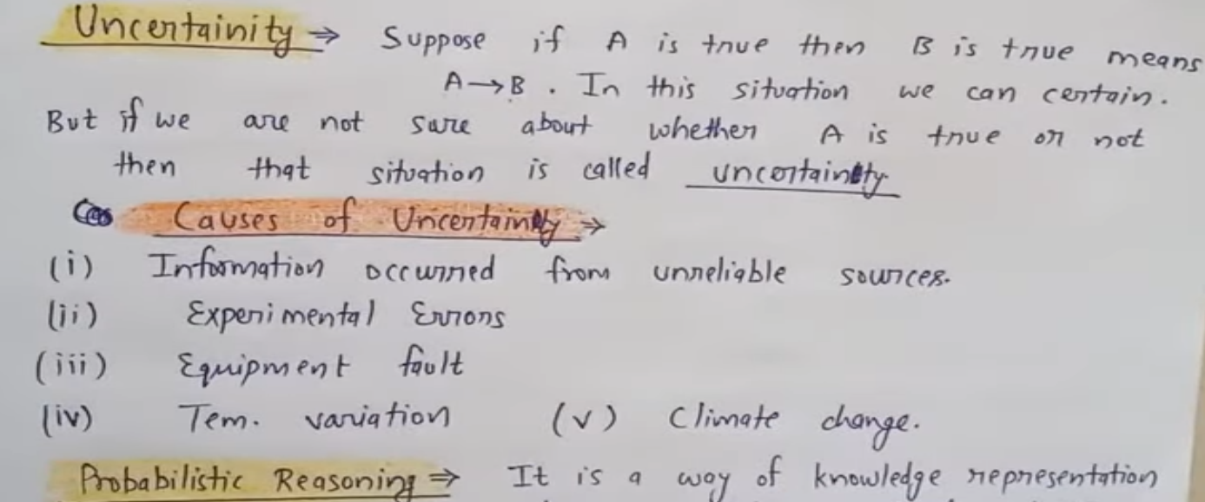

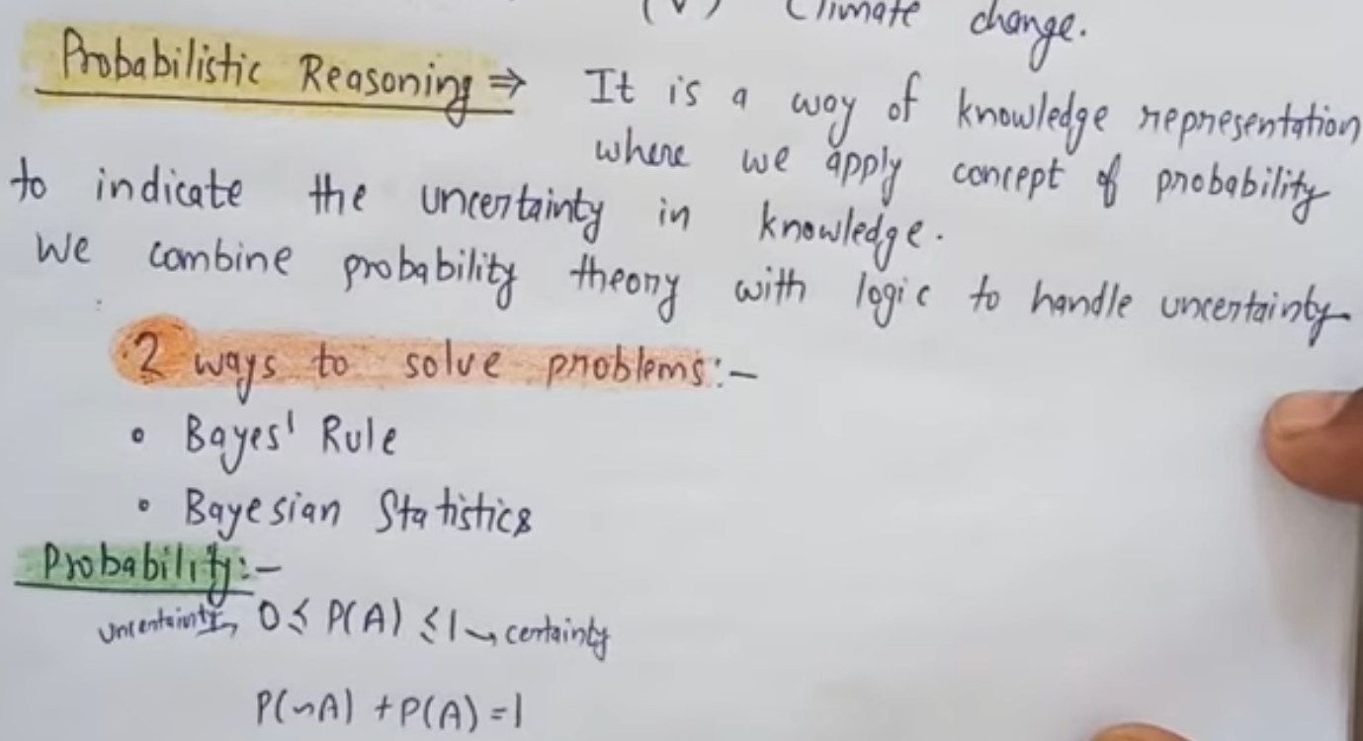

**Probability**

**Probability:** Probability can be defined as a chance that an uncertain event will occur. It is the numerical measure of the likelihood that an event will occur. The value of probability always remains between 0 and 1 that represent ideal uncertainties.

1. 0 ≤ P(A) ≤ 1,   where P(A) is the probability of an event A.
2. P(A) = 0,  indicates total uncertainty in an event A.
3. P(A) =1, indicates total certainty in an event A.

We can find the probability of an uncertain event by using the below formula.

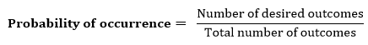

* P(¬A) = probability of a not happening event.
* P(¬A) + P(A) = 1.

## **Conditional probability:**

Conditional probability is a probability of occurring an event when another event has already happened.

Let's suppose, we want to calculate the event A when event B has already occurred, "the probability of A under the conditions of B", it can be written as:

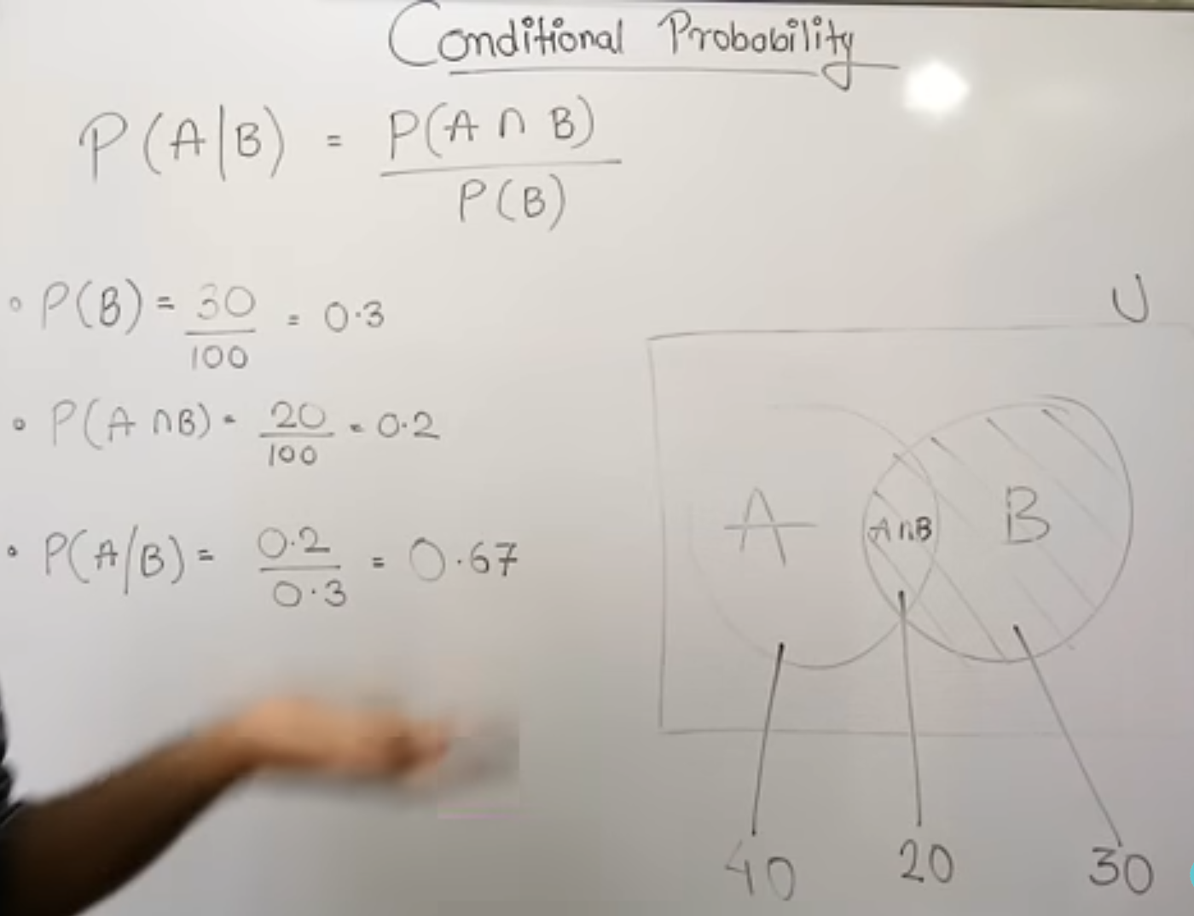

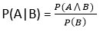

**Where P(A⋀B)= Joint probability of a and B**

**P(B)= Marginal probability of B.**

If the probability of A is given and we need to find the probability of B, then it will be given as:

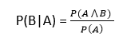

It can be explained by using the below Venn diagram, where B is occurred event, so sample space will be reduced to set B, and now we can only calculate event A when event B is already occurred by dividing the probability of **P(A⋀B) by P( B )**.

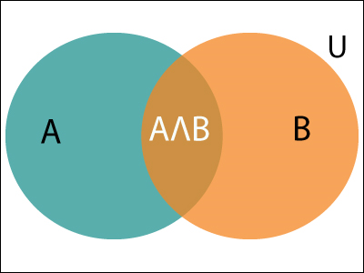

**Example:**

In a class, there are 70% of the students who like English and 40% of the students who likes English and mathematics, and then what is the percent of students those who like English also like mathematics?

**Solution:**

Let, A is an event that a student likes Mathematics

B is an event that a student likes English.

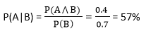

**Hence, 57% are the students who like English also like Mathematics.**

## **Bayes' theorem**

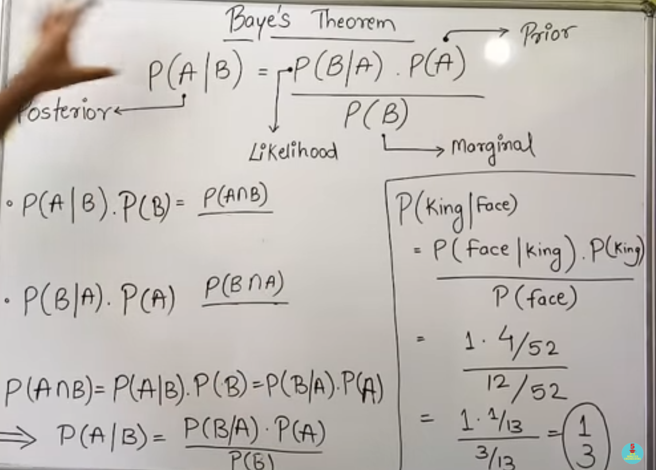



Bayes' theorem is also known as **Bayes' rule, Bayes' law**, or **Bayesian reasoning**, which determines the probability of an event with uncertain knowledge.

In probability theory, it relates the conditional probability and marginal probabilities of two random events.

Bayes' theorem was named after the British mathematician **Thomas Bayes**. The **Bayesian inference** is an application of Bayes' theorem, which is fundamental to Bayesian statistics.

It is a way to calculate the value of P(B|A) with the knowledge of P(A|B).

Bayes' theorem allows updating the probability prediction of an event by observing new information of the real world.

**Example**: If cancer corresponds to one's age then by using Bayes' theorem, we can determine the probability of cancer more accurately with the help of age.

Bayes' theorem can be derived using product rule and conditional probability of event A with known event B:

As from product rule we can write:

1. P(A ⋀ B)= P(A|B) P(B) or

Similarly, the probability of event B with known event A:

1. P(A ⋀ B)= P(B|A) P(A)

Equating right hand side of both the equations, we will get:

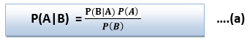

The above equation (a) is called as **Bayes' rule** or**Bayes' theorem**. This equation is basic of most modern AI systems for **probabilistic inference**.

**Bayesian network**

Bayesian Network show that what is the dependens and independens relationship between value or node in network.

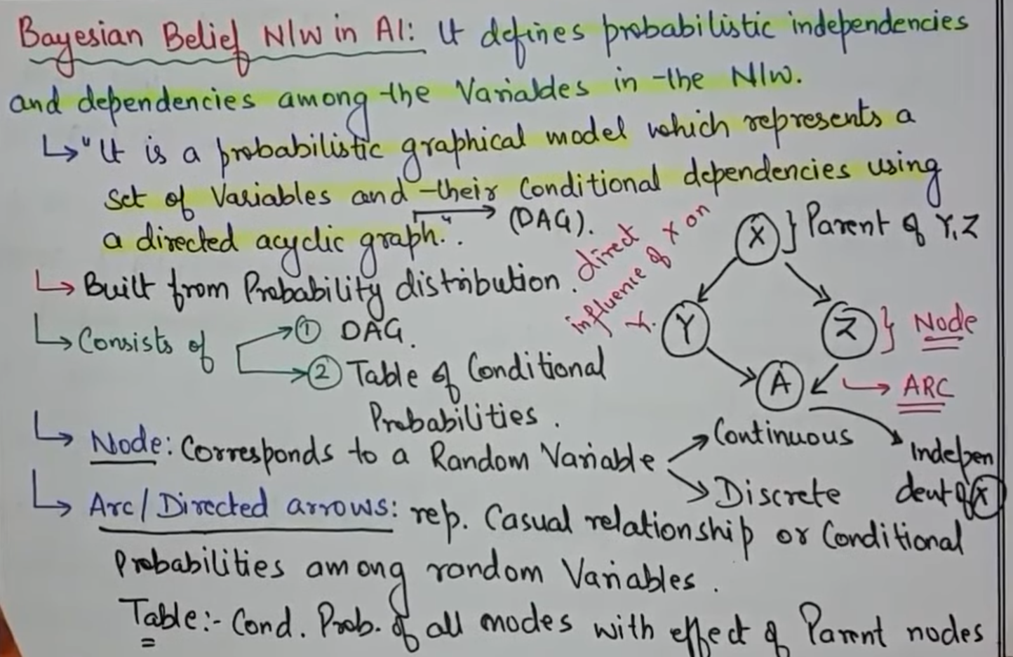

Bayesian Network can be used for building models from data and experts opinions, and it consists of two parts:

* **Directed Acyclic Graph**
* **Table of conditional probabilities.**

The generalized form of Bayesian network that represents and solve decision problems under uncertain knowledge is known as an **Influence diagram**.

**A Bayesian network graph is made up of nodes and Arcs (directed links), where:**

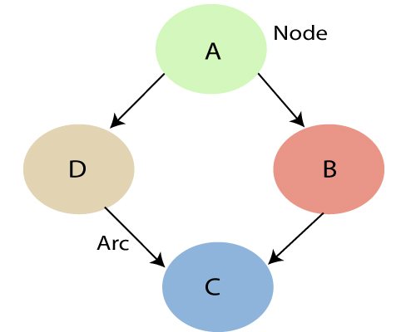

**Representation of Bayesian Network:-**

Bayesian networks are a probabilistic graphical model used to represent and reason about uncertainty in a system. They consist of a set of nodes (representing variables) and edges (representing the probabilistic dependencies between variables).

**Construction of Bayesian Network** 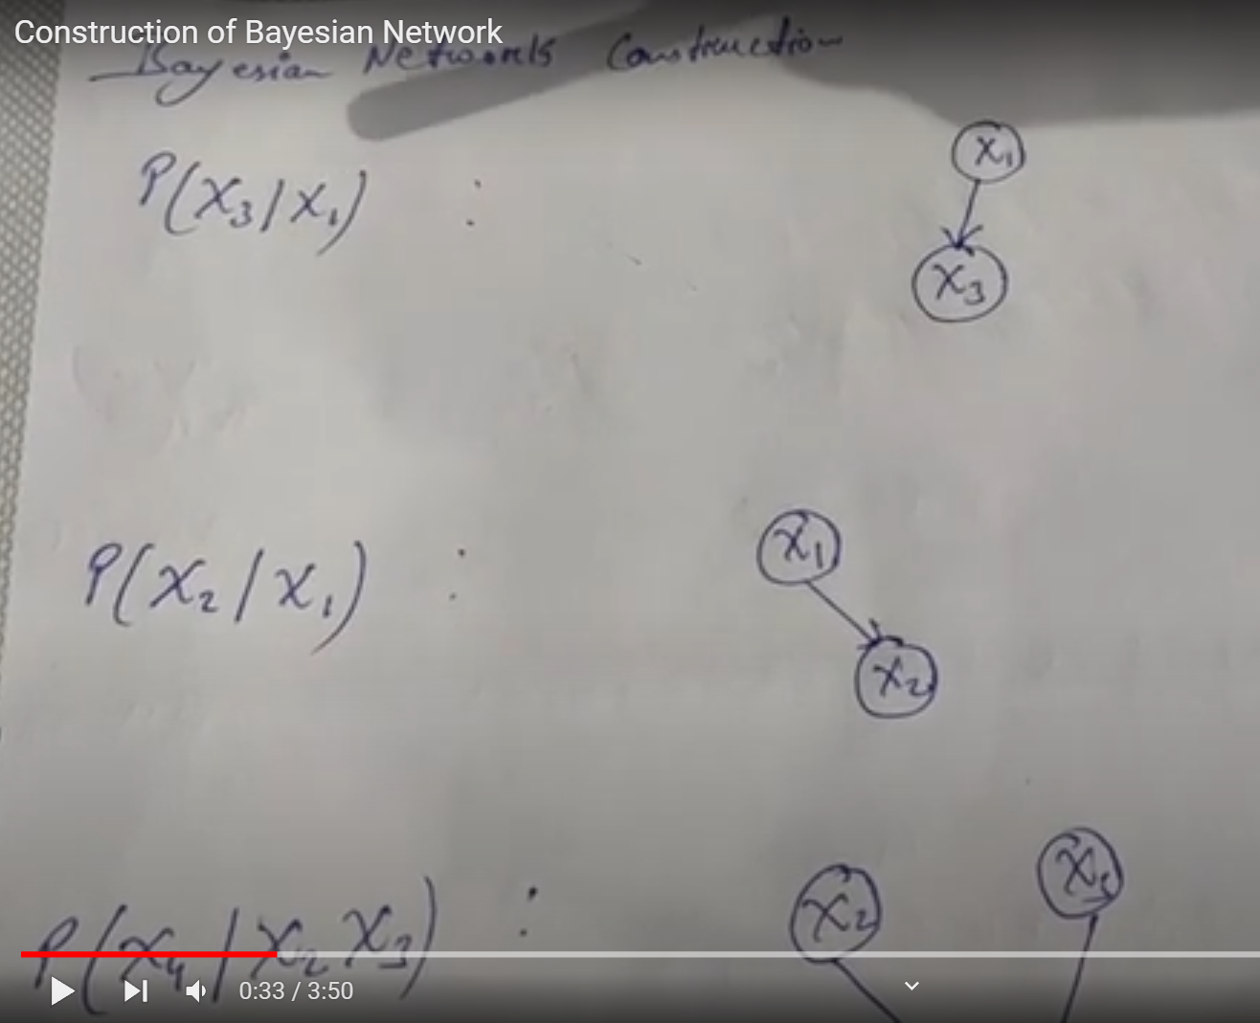

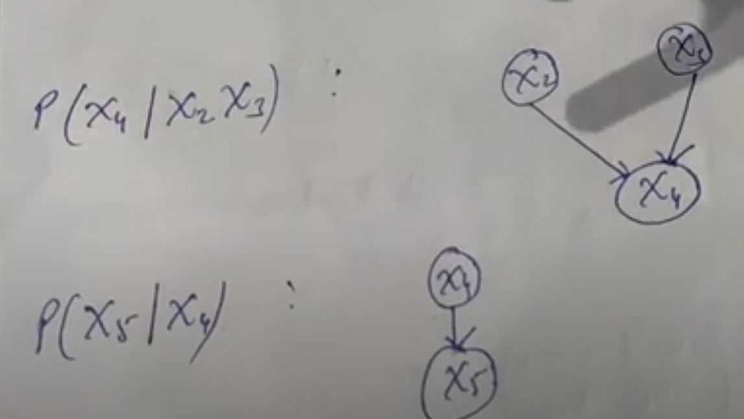

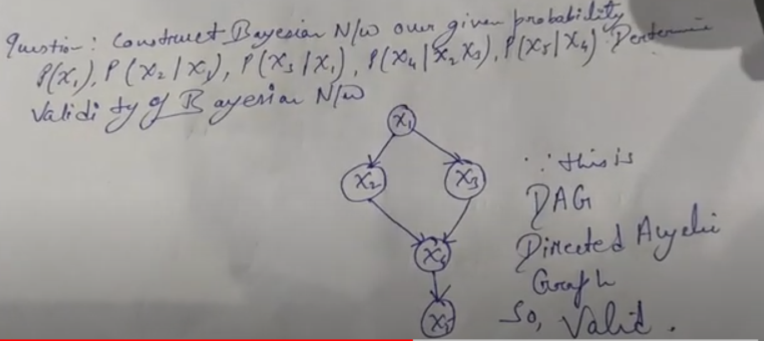

**Inference in Bayesian Network:-**

**Temporal Model:-**

Temporal models in AI are models that capture and analyze the dynamics and evolution of data over time. These models are used to make predictions, detect anomalies, and identify patterns in time-series data

**Hidden Markov Model:-**

HMM is a type of generative Temporal model that is used to model the probability of a sequence of observations given an underlying hidden state sequence.The main idea behind HMM is that the observable outputs depend on the hidden states, but the hidden states themselves are not directly observable. Instead, the hidden states can only be inferred from the observable outputs. HMM assumes that the state at any given time step depends only on the previous state, not on any other previous states.

**MDP(Markov Decision Process) Formulation:-**

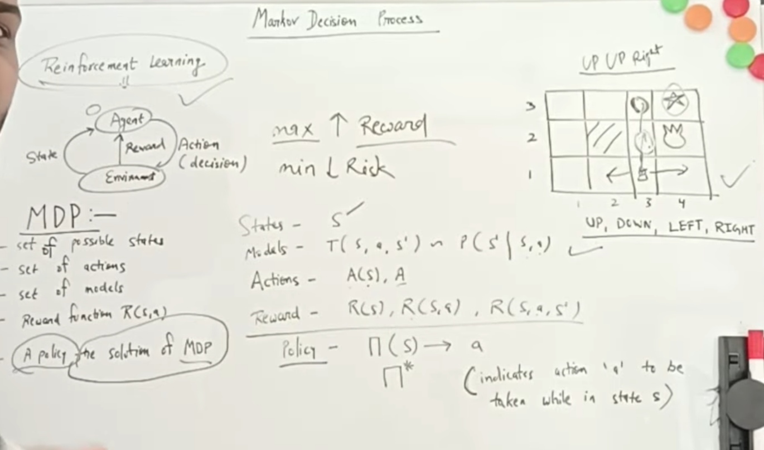

**Reinforcement Learning:-** Reinforcement learning is a type of Machine Learning and also It is part of AI. It`s allow machine and software to automatically determine the ideal behavior .

In Reinforcement Learning agent make decisions based on enviorment .firstly agent check enviorment and store data in state after that it`s take decision to next step. In this agent decide best option according to current step , when this step is repeat than that problem is called Markov Decision Process.

A **Markov Decision Process (MDP)** model contains: 

* A set of possible world states S.
* A set of Models.
* A set of possible actions A.
* A real-valued reward function R(s,a).
* A policy the solution of **Markov Decision Process**.

### What is a State?

A **State** is a set of tokens that represent every state that the agent can be in.

### What is a Model?

A **Model** (sometimes called Transition Model) gives an action’s effect in a state.

### What are Actions?

An **Action** A is a set of all possible actions. A(s) defines the set of actions that can be taken being in state S.

### What is a Reward?

A **Reward** is a real-valued reward function. R(s) indicates the reward for simply being in the state S. R(S,a) indicates the reward for being in a state S and taking an action ‘a’.

### What is a Policy?

A **Policy** is a solution to the Markov Decision Process. A policy is a mapping from S to a. It indicates the action ‘a’ to be taken while in state S.   
Let us take the example of a grid world:

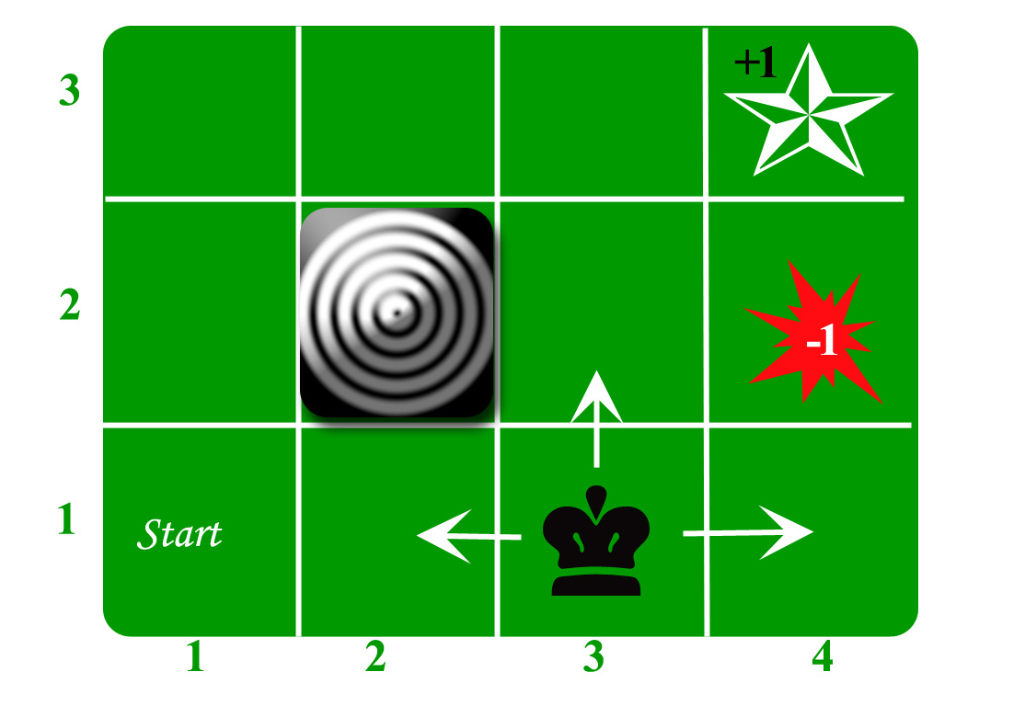

**Utility Theory**

Utility Theory is a type of decision theory That deal with how rational agent(rational/ideal agent means who know all things and who take best decision) should make decision.

Utility theory helps to take best decision to perform action.

Example :- In the world no one is the ideal , all have some negative behavior . So , in AI nothing is ideal but utility theory help to make ideal in AI , It`s help to make best decision in AI with help function theory .

In simple way we can say that utility theory help to make rational agent(rational agent means who know all things which have not any negative behavior) to perform any decision.

**Utility Function**

A utility function in AI is a mathematical function it is a way of quantifying an agent's preferences over possible outcomes in a decision-making problem.utility function also use in utility theory to make best decision from environment . utility function help to perform different type of function to achive best opation

**Value iteration** :-

Value iteration is a technique to optimize the best option . in value iteration , when we give the any Task to AI then it`s iterate each step and evaluate each step of task until it`s doesn`t found optimal decision . it is iterate each step to find error and to solve error of task.

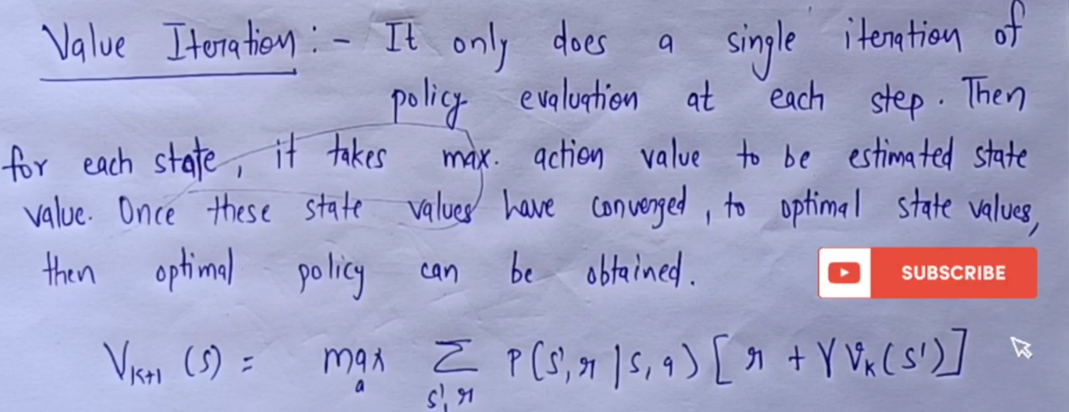

**Policy iteration:-**

Policy iteration is opposite of value iteration . policy iteration is also use for find the optimal decision in AI. But when we give the task to AI than firstly it is compile all step of task after that it is evaluate the task and find the error in Task.

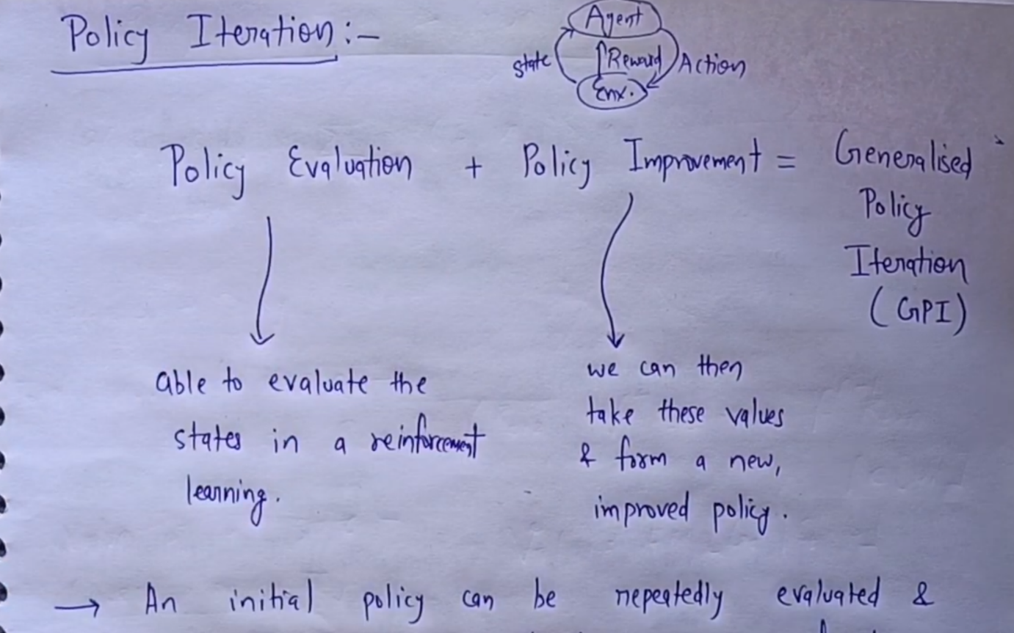

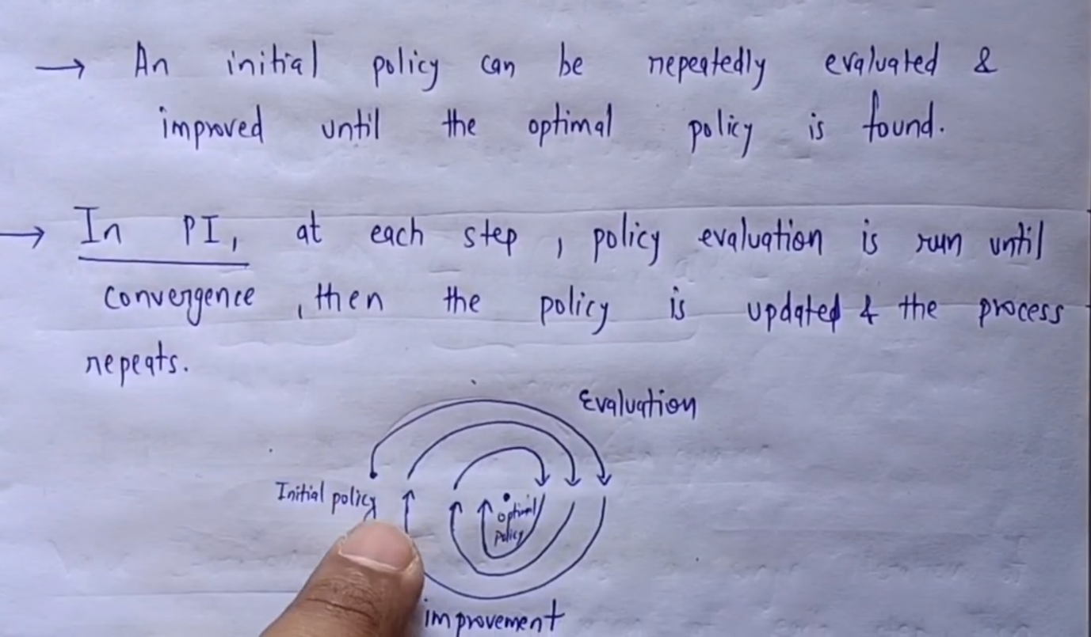

**Partial Observation**

Partial observation in AI refers to a scenario in which an agent is not able to observe the complete state of the environment in which it operates. This can occur in various settings, such as in robotics, where a robot may not have sensors that can fully capture the state of its environment, or in games like poker, where a player cannot observe the cards held by their opponents.

In such scenarios, the agent must rely on a partial observation of the environment to make decisions. This can make the problem of decision-making more challenging, as the agent may not have access to all the information it needs to make optimal decisions.

**UNIT – VI**

**Passive Rainforcement Learning**

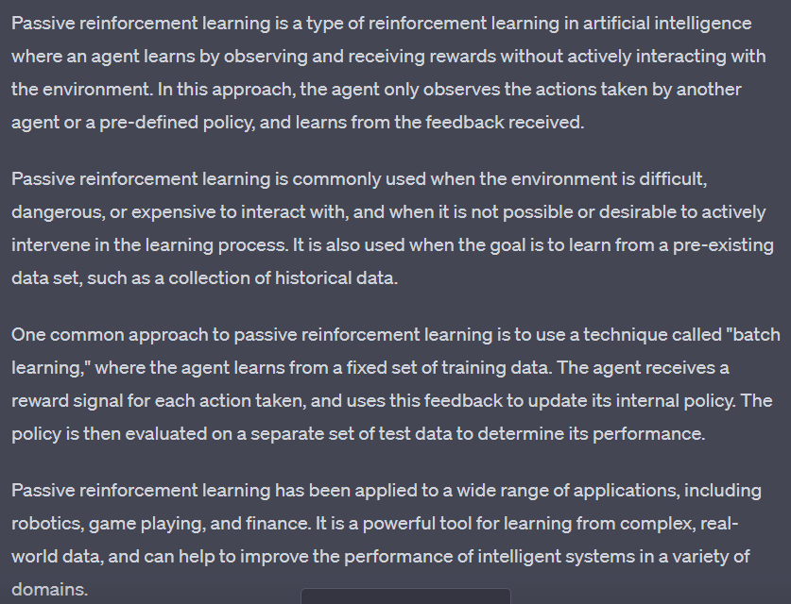

**Indirect utility Function**

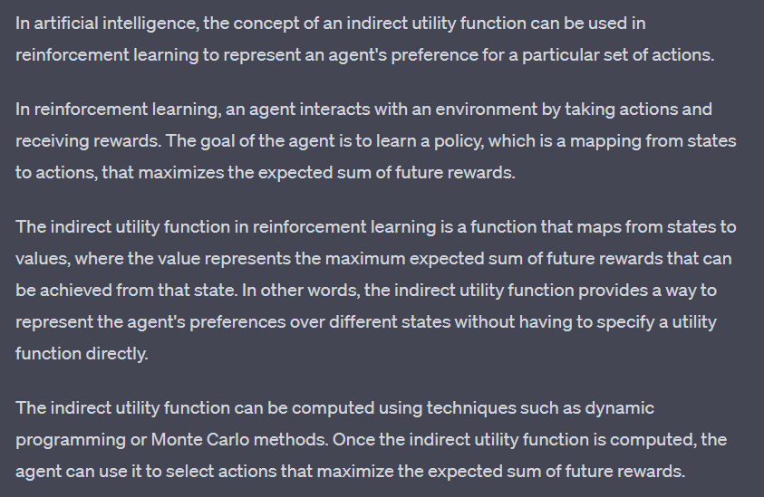

**Direct utility Estimation**

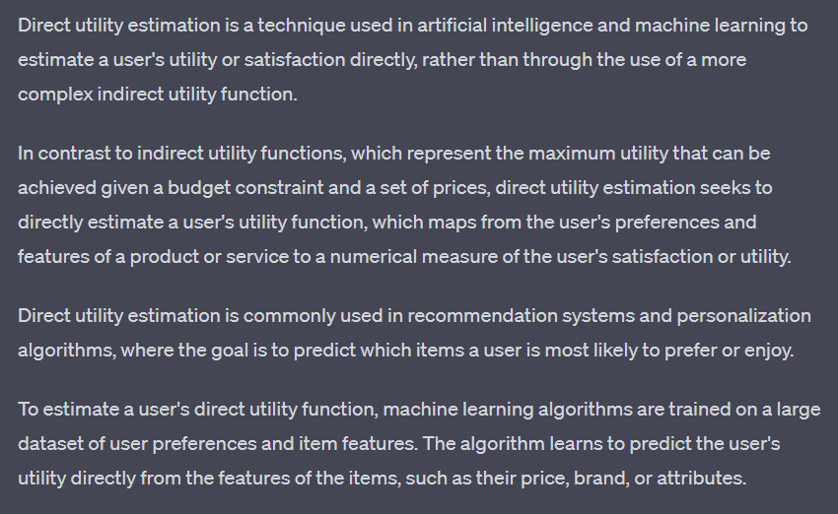

**Adpative Dynamic Programming**

Adaptive dynamic programming (ADP) is a reinforcement learning technique used in artificial intelligence. It is a method for learning optimal control policies in systems that exhibit nonlinear, time-varying behavior. ADP is particularly useful in systems where it is difficult or impossible to obtain a mathematical model.

In ADP, an agent learns by interacting with an environment and receiving rewards or penalties for its actions. The agent then uses this information to adjust its behavior in order to maximize its reward over time. The process of learning is iterative, with the agent updating its control policy after each interaction with the environment.

ADP combines ideas from dynamic programming and adaptive control theory to learn a control policy that optimizes a performance criterion, such as maximizing the expected cumulative reward. It is based on the principle of approximating the value function of a system using a function approximator, such as a neural network. The value function is used to guide the agent's actions in the environment.

One of the benefits of ADP is that it can be used in systems where the state space is very large or even continuous. By using a function approximator, ADP can generalize from past experience and make decisions based on incomplete or noisy information. However, it is important to note that ADP can suffer from the curse of dimensionality and can be computationally intensive.

Overall, ADP is a powerful technique for learning optimal control policies in complex systems. It has been successfully applied in a wide range of applications, including robotics, manufacturing, and finance.

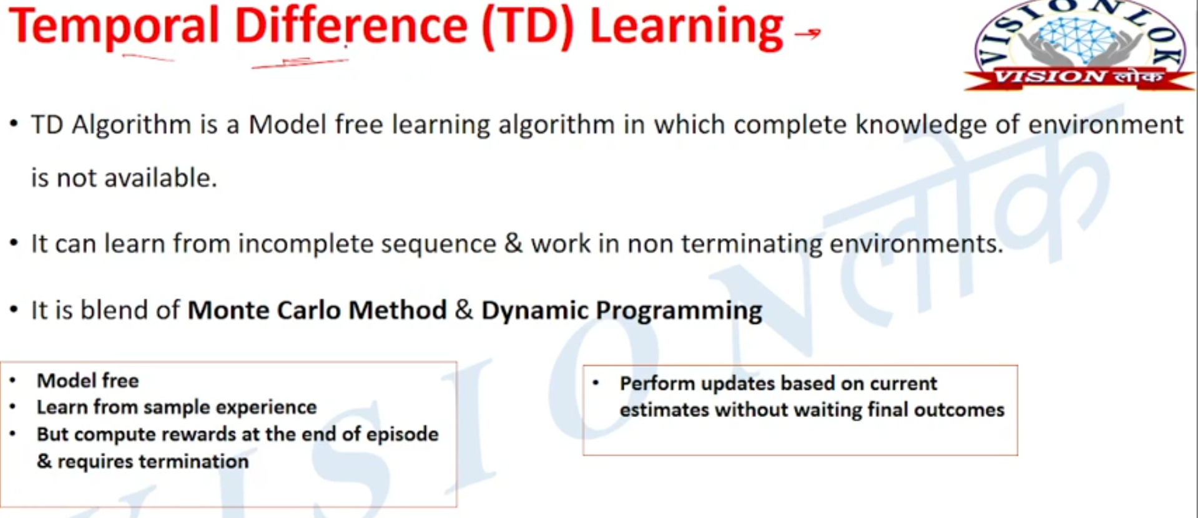**Temporal Difference Learning**

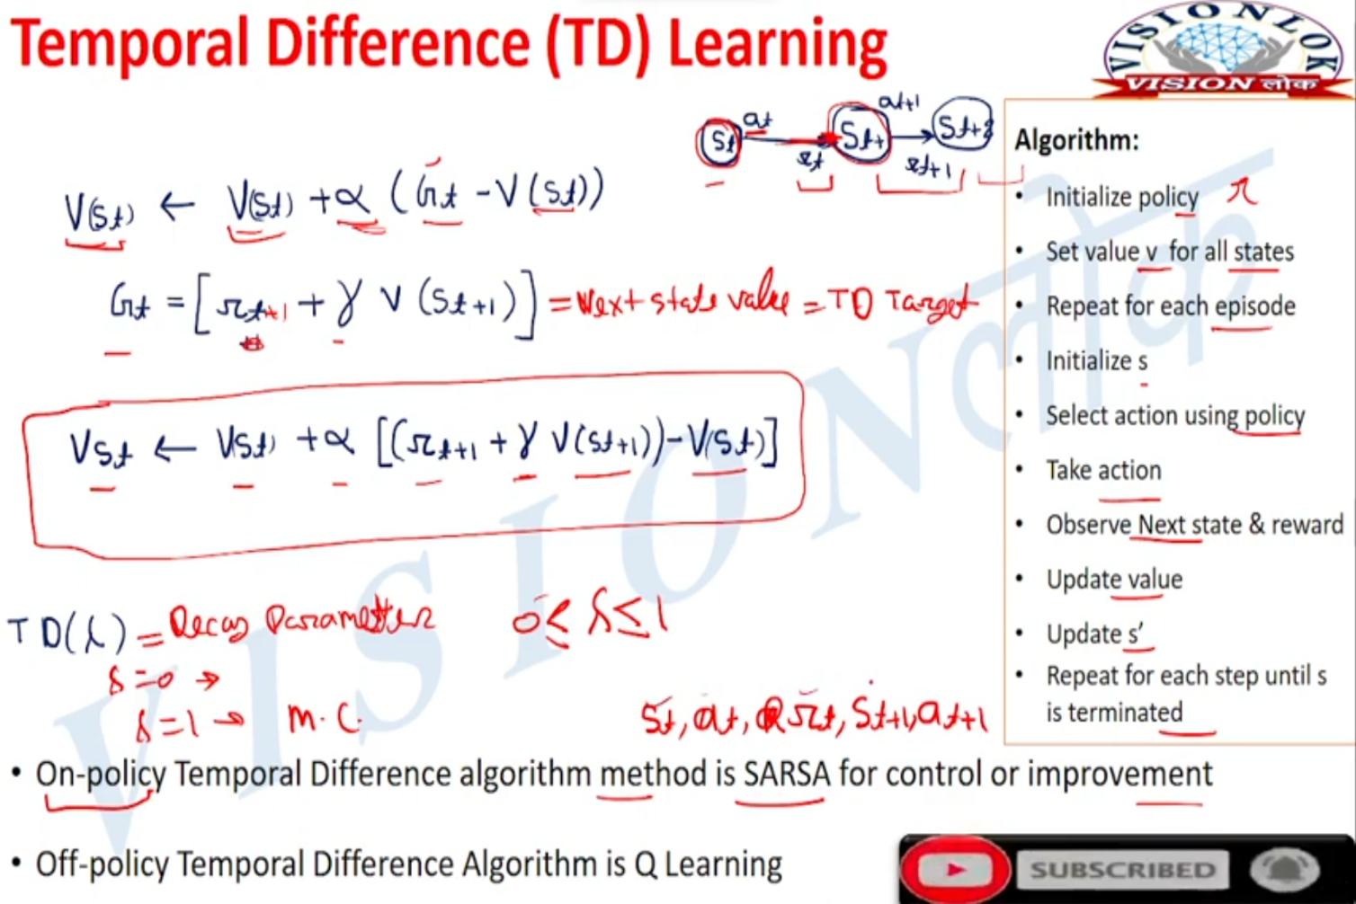

**Q-Learning**

Q-learning is a popular reinforcement learning algorithm used to solve problems where an agent must make a sequence of decisions in an environment in order to maximize a cumulative reward signal. The algorithm is model-free, meaning it does not require the agent to have any prior knowledge of the environment's dynamics or rules.

In Q-learning, the agent learns to estimate the value of taking a particular action in a particular state, known as the Q-value. The Q-value is an estimate of the expected cumulative reward the agent will receive by taking a particular action in a particular state and following an optimal policy thereafter. The optimal policy is the policy that maximizes the expected cumulative reward.

The algorithm updates the Q-value estimate for a given state-action pair based on the observed reward and the maximum Q-value of the next state. This update is known as the Q-learning update rule and is defined as:

Q(s, a) ← Q(s, a) + α [r + γ max(Q(s', a')) - Q(s, a)]

where Q(s, a) is the current Q-value estimate for the state-action pair (s, a), α is the learning rate, r is the observed reward for taking action a in state s, γ is the discount factor that determines the weight given to future rewards, and max(Q(s', a')) is the maximum Q-value estimate for all actions a' in the next state s'.

Q-learning is a powerful algorithm for solving a wide range of problems in reinforcement learning, including games, robotics, and control tasks. However, it is sensitive to the choice of hyperparameters, particularly the learning rate and the discount factor, and can be slow to converge in some cases.

Top of Form

